Doi:10.32604/cmc.2025.0xxxxx
ARTICLE
Optimized Multi-Scale Feature Fusion with BGL-YOLO11 for Aerial Object Detection
Donghai Peng ^{1, *}, Huanjie Yu ² and Huajin Jiang ¹
¹School of Information Engineering, Shaoguan University, Shaoguan, 512005, China
²School of Computer Science, Hunan University of Technology and Business, Changsha, 410205, China
*Corresponding Author: Donghai Peng. Email: semhaqx@gmail.com
Received: Day Month Year; Accepted: Day Month Year; Published: Day Month Year
ABSTRACT: To address the challenges of small target scale, severe occlusion, and complex back-grounds in drone-based vision, traditional YOLO-based detectors still suffer from high missed detection rates and imprecise localization, particularly in low-altitude aerial scenarios such as VisDrone. To improve YOLO11's performance in drone-based scenarios, we propose an improved detection network, BGL-YOLO11, which integrates the Bidirectional Feature Pyramid Network (BiFPN), Global-Local Spatial Attention Module (GLSA), and Lightweight Adaptive Weight Downsampling Module (LAWDS). BiFPN efficiently fuses multi-scale features, enhancing small target representation; GLSA models global context and local details to suppress background interference; LAWDS adaptively recalibrates and enhances features without significantly increasing parameters. On the Vis-Drone dataset, we perform comparative experiments with YOLO11n as the baseline and design multiple ablation combinations. The results show that BGL-YOLO11 improves mAP@0.5 and mAP@0.5:0.95, significantly enhances small target recall, and maintains real-time inference speed, with minimal computational cost increase. These findings validate the effectiveness of BiFPN, GLSA, and LAWDS for small target detection in drone environments. BGL-YOLO11 shows strong engineering application potential in complex drone scenarios.
KEYWORDS: Object Detection; YOLO11; GLSA; BiFPN; LAWDS

1 Introduction
With the rapid development of deep learning and computer vision technologies, object detection has become a crucial task in numerous real-world applications, ranging from autonomous driving and surveillance to aerial monitoring via Unmanned Aerial Vehicles (UAVs) (1). YOLO (You Only Look Once) models, due to their remarkable ability to balance speed and accuracy, have become the de facto standard for real-time object detection(2). In particular, YOLO models have gained widespread adoption across various domains, including intelligent transportation systems, security surveillance, and even aerial imaging for environmental monitoring(3). However, despite the success of YOLO in these domains, significant challenges remain when applying traditional YOLO models to specialized tasks, such as UAV-based detection(4).
UAV-based object detection tasks present unique difficulties, many of which are not fully addressed by traditional YOLO models trained on general-purpose datasets like COCO(5). UAVs capture images from an aerial perspective, which introduces challenges such as small object sizes, occlusions caused by varying object orientations, and complex and cluttered backgrounds(6). These issues are particularly prominent in urban and rural infrastructure inspections, where small targets are often occluded or submerged in complex visual noise, leading to a high rate of missed detections and imprecise localization(7). Furthermore, the significant variation in target sizes, the shifting angle of view, and environmental factors like lighting conditions further complicate the accurate detection of small objects(8).
While existing YOLO models excel in detecting large objects in relatively simple environments, they struggle with small target detection in UAV scenarios(9). This is primarily due to their inability to adapt well to the variations in scale and the complex backgrounds characteristic of aerial imagery(10). Additionally, models pretrained on general-purpose datasets like COCO tend to underperform when directly applied to domain-specific datasets, such as VisDrone, which features a variety of small, occluded, and often cluttered objects in UAV-captured images(11).
Addressing these limitations has prompted extensive research into various techniques aimed at improving the performance of object detection models in UAV-based environments(12). One key area of focus has been multi-scale feature fusion(13). The ability to integrate features from different scales within the neural network allows models to detect objects of varying sizes more effectively(14). Traditional multi-scale fusion methods, such as Feature Pyramid Networks (FPN) and Pyramid Attention Networks (PAN), have been widely used to enhance detection across different resolutions by combining features from different layers of the network(15). However, despite their successes, these methods are limited in their ability to efficiently process features from multiple scales, particularly in the context of UAV imagery where fine-grained details are crucial for small target detection(16).
The introduction of Bidirectional Feature Pyramid Networks (BiFPN) represents a major advancement in multi-scale fusion, offering more efficient fusion by enabling bidirectional information flow across the feature pyramids(17). This bidirectional fusion helps retain both high- and low-level features, allowing for more accurate detection of small targets, particularly in complex environments(18). The BiFPN module is a significant enhancement over traditional FPN-based methods, as it not only facilitates better feature aggregation but also enhances the robustness of the model against background noise and occlusion, which are prevalent in UAV scenarios(19).
Along with multi-scale fusion, attention mechanisms have become an integral part of modern object detection architectures(20). Attention modules, such as Squeeze-and-Excitation Networks (SENet) and Convolutional Block Attention Modules (CBAM), help the model focus on relevant regions of an image while suppressing irrelevant background information(21). This is particularly beneficial in UAV-based detection tasks, where small objects are often obscured by cluttered and noisy environments(22). However, while attention mechanisms improve the focus on small targets, they come with an increase in computational complexity, which can slow down real-time inference(23). Therefore, designing lightweight and efficient attention mechanisms that do not significantly increase the model's computational load is critical for practical applications in UAV-based systems(24).
To address these challenges, this paper proposes BGL-YOLO11, an enhanced YOLOv11 architecture specifically designed for small target detection in UAV-based environments(25). BGL-YOLO11 integrates three key modules: BiFPN, Global-Local Spatial Attention (GLSA), and Lightweight Adaptive Weight Downsampling (LAWDS), all of which work together to improve small object detection performance in complex and cluttered backgrounds while maintaining high computational efficiency(26).
The key contributions of this work are as follows:
1. BiFPN for Efficient Multi-Scale Fusion(27): We replace the traditional FPN with BiFPN in the YOLOv11 backbone. BiFPN facilitates bidirectional communication between different feature levels, allowing for more efficient feature fusion and improved small object detection, particularly in challenging UAV scenarios where traditional methods often fail to capture crucial details.
2. GLSA for Enhanced Attention(28): We integrate the GLSA attention module to model both global context and local spatial details. This module helps the model suppress background interference and focus on small objects, especially in environments where occlusions and cluttered backgrounds are prevalent.
3. LAWDS for Lightweight Feature Enhancement(29): LAWDS is introduced to adaptively recalibrate and enhance multi-scale features without significantly increasing the model's parameter count. This lightweight enhancement ensures that small object detection is improved while maintaining real-time processing speeds, making it suitable for deployment in resource-constrained environments like UAVs.
This paper conducts extensive experiments on the VisDrone dataset to evaluate the performance of BGL-YOLO11 compared to the baseline YOLOv11 model. We also perform an ablation study, testing various combinations of the proposed modules to determine their individual and collaborative contributions. The results demonstrate significant improvements in both mAP@0.5 and mAP@0.5:0.95, alongside enhanced small target recall and minimal increase in computational cost.
Overall, BGL-YOLO11 shows strong promise for real-world applications in UAV-based scenarios, including urban surveillance, infrastructure monitoring, and other inspection tasks where accurate detection of small, occluded, or distant objects is crucial. The proposed model addresses several critical challenges in UAV-based object detection, offering a balance of high accuracy, efficiency, and robustness, with potential applications in a wide range of industries.

2 Related Work

2.1 YOLO Series and Evolution
The YOLO (You Only Look Once) series of object detection models have seen multiple iterations, each offering improvements in speed, accuracy, and efficiency. The most recent, YOLOv11, represents a significant advancement over previous versions, particularly in its ability to handle small targets in complex environments. YOLO models are widely known for their real-time performance, achieving a balance between high detection accuracy and computational efficiency, making them suitable for various applications such as surveillance, autonomous driving, and UAV-based monitoring(30).
While earlier versions such as YOLOv3 and YOLOv4 were successful in various detection tasks, YOLOv11 introduces key architectural updates that set it apart. Notably, the upgrade from C2f to the C3k2 module in the backbone network optimizes feature extraction, enhancing the ability to detect smaller and more challenging targets. YOLOv11 also integrates a novel C2PSA (Cross-Stage Partial Attention) module that improves feature representation, particularly for occluded and multi-scale objects, a critical feature in real-world applications where target sizes and appearances can vary dramatically(31).
Despite the improvements in detection accuracy, challenges persist in deploying YOLOv11 in environments where the objects are highly variable in scale, occluded, or obscured by complex backgrounds. Traditional multi-scale feature fusion methods, such as Feature Pyramid Networks (FPN) and Pyramid Attention Networks (PAN), have been effective but often fail to handle more intricate scenarios, such as UAV-based surveillance tasks, where the scale of targets may differ significantly due to altitude variations or perspective distortions. To address this, YOLOv11 incorporates BiFPN (Bidirectional Feature Pyramid Network), which improves multi-scale feature fusion by enabling bidirectional communication between feature maps, thus better capturing fine details of small targets.

2.2 Enhancements and Modifications to YOLOv11
Although YOLOv11 provides a solid foundation for object detection tasks, several improvements have been explored in the literature to further enhance its performance, particularly for UAV-based applications that demand high accuracy under challenging conditions. One of the key challenges in UAV-based object detection is dealing with the wide range of object scales and cluttered backgrounds. To address these issues, recent work has focused on integrating advanced attention mechanisms and optimizing feature fusion processes to boost the model's robustness.
The integration of attention mechanisms, such as SENet (Squeeze-and-Excitation Networks) and CBAM (Convolutional Block Attention Module), has shown to improve the model's focus on relevant features while suppressing background noise, which is critical in environments with high levels of occlusion. However, while attention mechanisms improve accuracy, they often come at the cost of increased computational demand, making it difficult to deploy such models on resource-constrained devices like drones(32).
To mitigate these challenges, this study proposes BGL-YOLO11, an enhanced version of YOLOv11, which incorporates three primary modifications aimed at improving small object detection in complex environments. The model integrates BiFPN for efficient multi-scale feature fusion, GLSA (Global-Local Spatial Attention) to further enhance feature sensitivity in complex backgrounds, and LAWDS (Lightweight Adaptive Weight Downsampling), which reduces computational overhead while maintaining accuracy.
The BiFPN module, as part of the neck network, allows for efficient and bidirectional feature fusion, which helps the model better capture fine-grained details and improves the detection of small targets. The GLSA module enhances the model's ability to adaptively focus on both global context and local details, which is crucial for detecting occluded or overlapping objects in aerial imagery. Lastly, LAWDS offers a lightweight approach to enhance multi-scale feature recalibration without significantly increasing the model’s parameter count, thus making it suitable for deployment in UAV-based systems(33).
These modifications allow BGL-YOLO11 to outperform the original YOLOv11 model, particularly in detecting small targets in low-altitude aerial imagery, making it a promising solution for real-world UAV-based detection tasks.
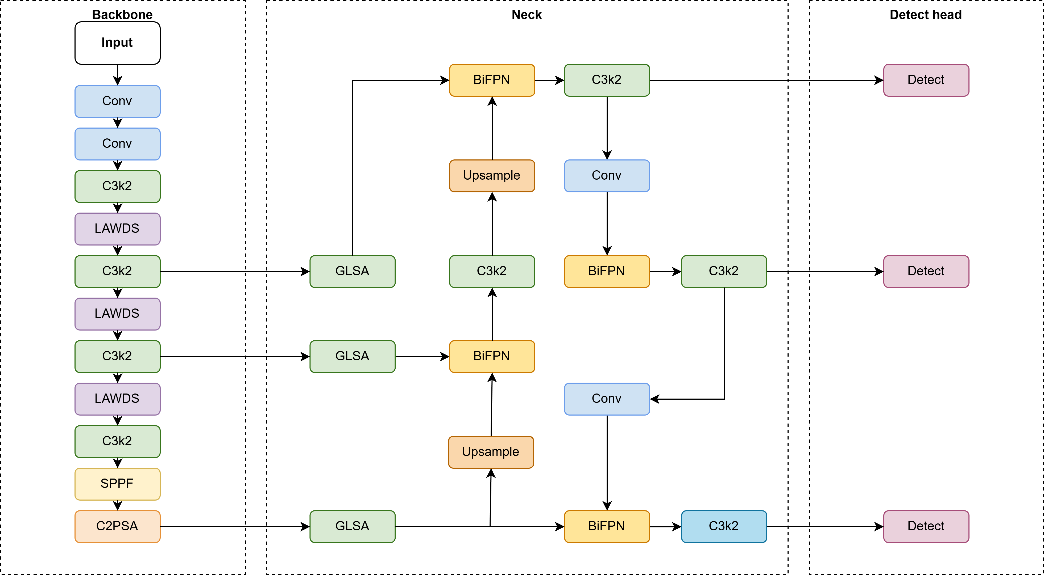
Figure 1: The model architecture after improvement of YOLOv11

2.2.1 BiFPN (Bidirectional Feature Pyramid Network)
The Bidirectional Feature Pyramid Network (BiFPN) is an enhanced version of the traditional Feature Pyramid Networks (FPN), specifically designed to improve multi-scale feature fusion. In object detection tasks, particularly in UAV-based detection, the ability to accurately capture features from various scales is crucial, as UAV imagery often contains small targets, large occlusions, and complex backgrounds.
As illustrated in Figure 2, BiFPN works by facilitating bidirectional communication between different levels of feature maps. This enables both fine-grained details and coarse features to be effectively combined, unlike traditional FPN, which uses a top-down approach. BiFPN achieves this by employing upsampling and downsampling strategies, allowing feature maps at various levels to interact, as shown in the diagram. Feature maps are concatenated (Concat+Conv) and processed by convolutional operations to refine the representation, enhancing the model's ability to detect objects across multiple scales.
A key innovation in BiFPN is the introduction of learnable weights for feature maps. These weights are dynamically adjusted during training, allowing the model to focus on the most relevant features for the given task, while suppressing irrelevant information. This ability is particularly beneficial for small object detection, where features from lower-resolution feature maps might otherwise be underutilized.
The weighted feature fusion in BiFPN can be represented by the following formula:
$$O=\sum_{i=1}^{n}{w_{i}F_{i}}$$ | (1)
Where$O$is the output feature map, $F_{i}$represents the input feature maps, and$w_{i}$are the learnable weights assigned to each feature map. The weights are normalized to maintain stability during training.
BiFPN brings several advantages to the YOLO11 architecture:
1. Efficient Multi-Scale Feature Fusion: The bidirectional feature fusion enables the model to capture more fine-grained details and context, which is essential for detecting small objects in complex aerial images.
2. Feature Prioritization: The learnable weights help the network prioritize more important features, leading to better detection accuracy, especially for small and occluded objects.
3. Computational Efficiency: Despite the complexity of bidirectional fusion, BiFPN remains efficient, reducing the number of operations compared to traditional FPNs and making it suitable for real-time applications in UAV detection.
By incorporating BiFPN into the YOLO11 framework, we significantly enhance the model's ability to handle small target detection and complex environments, making it better suited for practical deployment in UAV-based object detection tasks.
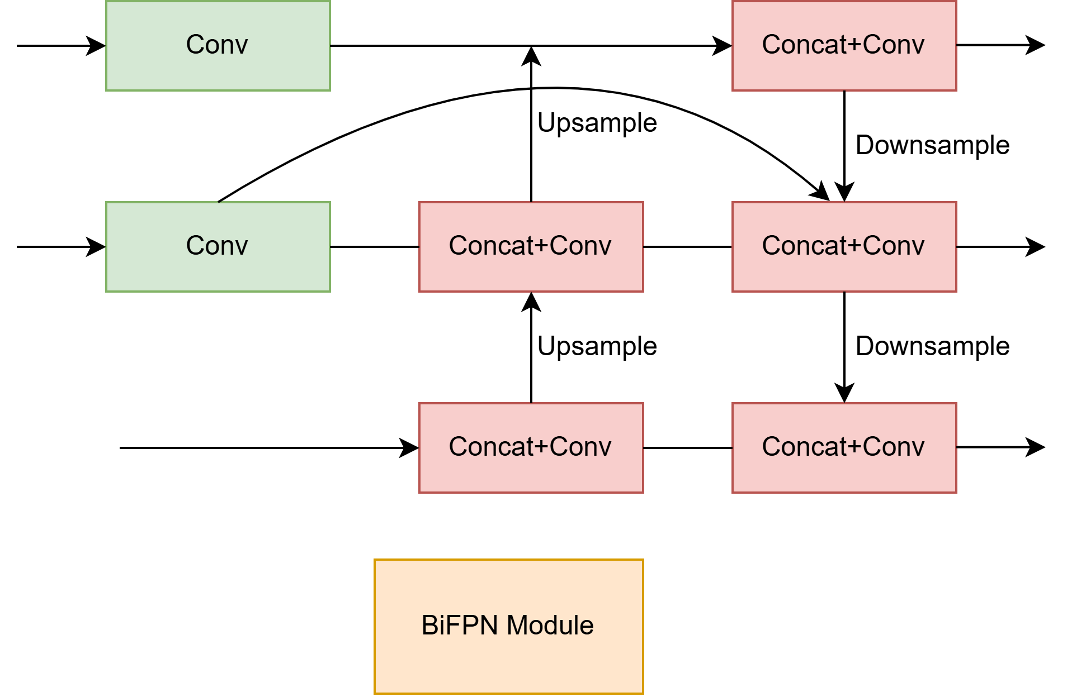
Figure 2: Structure of the BiFPN module

2.2.2 GLSA (Global-Local Spatial Attention)
The Global-Local Spatial Attention (GLSA) module is introduced to address the limitations of traditional attention mechanisms in detecting small and occluded objects, particularly in UAV-based imagery. While existing attention mechanisms like SENet and CBAM focus on either spatial or channel-wise attention, they do not fully utilize both global context and local spatial details. This limitation results in suboptimal performance when detecting small objects in complex environments, especially those that are partially or fully occluded. These issues are further compounded by cluttered and dynamic backgrounds, which hinder the model’s ability to distinguish between objects of interest and background noise. GLSA, by contrast, models both global context and local spatial features simultaneously, allowing the network to effectively highlight relevant areas of an image while suppressing irrelevant background noise that often obscures important features(34).
The global context modeling in GLSA helps the network capture long-range dependencies and understand the broader scene. In UAV-based detection tasks, aerial imagery often includes large portions of background, which can significantly vary in terms of texture, color, and structure. By incorporating global context, GLSA provides the model with a better understanding of the entire image, enhancing its ability to distinguish between foreground objects and background clutter. This is particularly important in aerial views where background context plays a crucial role in correctly interpreting the spatial relationship between objects. The integration of global context allows the model to focus on the relevant spatial features that contribute to better object localization and classification, particularly when there are overlapping objects or dense scenes.
On the other hand, the local spatial attention mechanism within GLSA enhances the model’s ability to focus on specific regions in the image where small or occluded objects are located. In the presence of large variations in background or when objects are partially obstructed, traditional attention mechanisms may fail to capture fine-grained details. The local spatial attention, however, allows the model to zoom in on smaller, more intricate details, improving detection accuracy in highly complex environments. For example, in UAV surveillance of urban areas, objects such as pedestrians, vehicles, or infrastructure can often be hidden behind buildings or trees, and these occlusions can significantly reduce detection accuracy. The local spatial attention mechanism helps mitigate this challenge by giving more focus to the relevant regions that contain the target objects, even when they are occluded or small in scale.
By combining these two attention strategies, GLSA boosts the sensitivity of the model to small, occluded, or distant objects, ensuring that fine-grained details are captured. The dual focus on both global and local features allows GLSA to maintain robust performance even in environments where traditional models might struggle. The global context helps the model understand the overall scene, while the local spatial attention hones in on the crucial details that are typically harder to detect. This combination makes GLSA highly effective in handling the challenges posed by UAV-based object detection tasks, where both global context and precise localization of small objects are essential for accurate detection.
The integration of GLSA into the YOLO11 architecture allows the model to benefit from enhanced feature maps, which provide richer representations of the image content. This improvement in feature representation enhances the model's ability to detect small and occluded objects with higher accuracy, particularly in complex environments such as urban surveillance or infrastructure monitoring. In these applications, detecting small, hidden, or occluded objects is critical, and GLSA’s ability to prioritize important features while suppressing irrelevant noise leads to better detection results. This enhanced performance translates into more reliable and efficient detection systems for UAVs, enabling real-time applications where object detection must be both fast and accurate.
Moreover, the combination of global and local attention mechanisms in GLSA improves the model's adaptability to diverse environmental conditions. This adaptability is crucial for UAV-based object detection, where varying lighting, weather conditions, and dynamic backgrounds can all affect the quality of the images. By learning to focus on both broader contextual information and detailed spatial features, GLSA allows the model to be more robust to such environmental variations. This results in improved detection accuracy across a wide range of conditions, making GLSA a highly effective component for enhancing the performance of UAV-based detection systems.
The proposed GLSA module significantly enhances YOLO11’s ability to focus on key regions of interest, improving its overall detection performance in real-world scenarios. Its ability to jointly model global context and local spatial features allows it to handle complex, cluttered environments with high efficiency, ultimately making it a powerful tool for UAV applications. Whether it’s detecting small objects in urban surveillance or monitoring infrastructure in remote areas, GLSA provides the necessary improvements to ensure robust and reliable detection performance.
The GLSA module combines global and local attention mechanisms. The input feature map F is processed through two attention branches: the Global Spatial Attention (GSA) and the Local Spatial Attention (LSA). These branches produce$F_{global}$and$F_{local}$respectively. The final output$F_{GLSA}$is a weighted combination of these two, formulated as:
$$F_{GLSA}=concat(F_{global},F_{local})∙W_{GLSA}$$ | (2)
Where$F$is the input feature map, $F_{global}$and$F_{local}$are the outputs from the global and local attention mechanisms, $W_{GLSA}$is the learnable weight matrix that combines both global and local features into the final output.
This${ F}_{GLSA}$output is then used to enhance the feature maps, improving detection performance for small, occluded, and distant objects in UAV imagery.
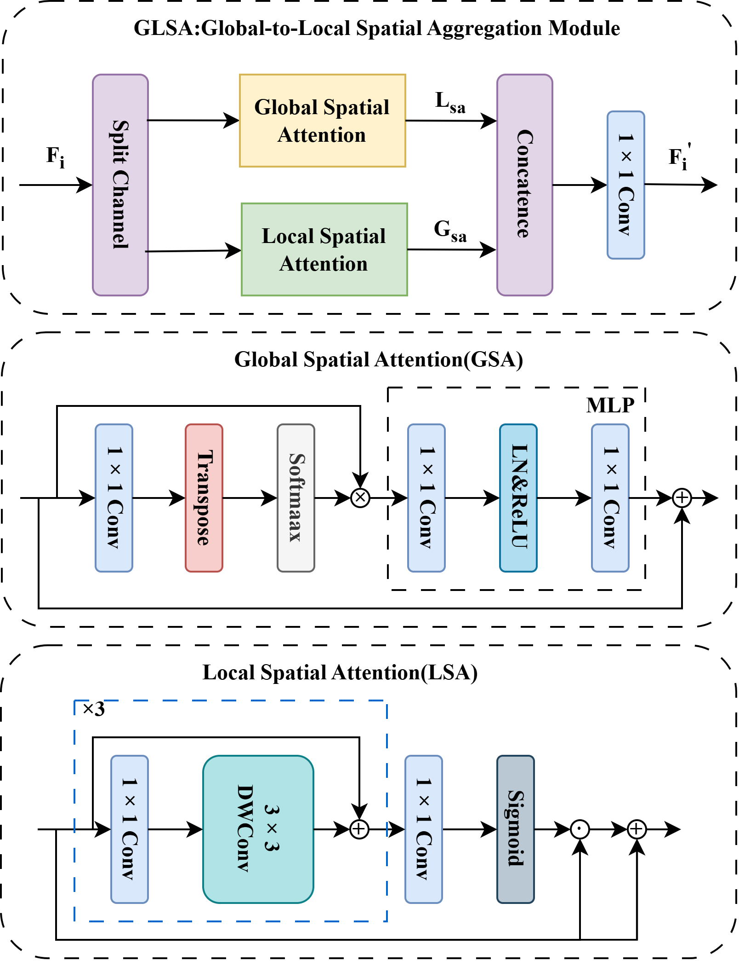
Figure 3: Structure of the GLSA module

2.2.3 LAWDS (Lightweight Adaptive Weight Downsampling)
The LAWDS (Lightweight Adaptive Weight Downsampling) module is designed to improve small object detection in complex environments, specifically in UAV-based aerial imagery. Small, occluded, or distant objects are particularly challenging to detect in such scenarios. LAWDS addresses this issue by providing an adaptive recalibration and enhancement mechanism that operates across multiple scales while maintaining computational efficiency. This design is particularly advantageous for UAV applications, where lightweight models are required for real-time performance, especially on resource-constrained devices(35).
As shown in Figure 4, the LAWDS module begins by passing the input feature map through an average pooling layer, reducing its spatial resolution. This is followed by a series of convolutional operations that capture multi-scale features. A key part of LAWDS is the adaptive weighting mechanism, which adjusts the contribution of each feature based on its relevance to detecting small objects. This helps focus the model’s attention on important features while suppressing irrelevant background noise.
The core operation of the LAWDS module is governed by the following equation:
$$F_{enhanced}=F∙(σ(W∙F+b))$$ | (3)
Where$F$represents the input feature map, which is of size$C×H×W$, where C is the number of channels, and$H$and$W$are the height and width of the feature map, respectively,$W$is the learnable weight matrix, which adjusts the contribution of each feature based on its relevance for detecting small or occluded objects,$b$is the bias term, used to control the feature recalibration process,$σ$is the activation function, either Sigmoid or Softmax, which generates attention weights that prioritize important features for small object detection, $F_{enhanced}$is the output feature map, which has been enhanced by applying attention weights to the original input feature map.
The LAWDS module enhances small object detection by focusing on the most relevant features and suppressing noise. The adaptive recalibration allows the model to better capture fine-grained details, especially in aerial imagery where objects vary significantly in scale and are often partially occluded by other objects. In environments like these, where background clutter and occlusions are prevalent, the module ensures that the network can detect small targets more effectively.
What sets LAWDS apart from other feature enhancement modules is its lightweight design, which ensures that it can be deployed efficiently on UAVs without introducing significant computational overhead. This makes LAWDS an ideal solution for real-time UAV applications, where resources are limited and speed is crucial. The module enhances small object detection without compromising performance, ensuring that even small or distant targets can be detected in cluttered environments.
Additionally, LAWDS is seamlessly integrated into the YOLO11 architecture. By enhancing the output of the BiFPN and GLSA modules, it refines the model’s ability to focus on critical regions of interest, such as small or occluded objects. The integration of LAWDS thus complements the other modules, enabling the model to achieve superior detection accuracy without the need for additional computational resources. This synergy between LAWDS, BiFPN, and GLSA results in a more robust detection model for UAV-based applications, where detecting small objects in complex environments is a key challenge.
Figure 4 illustrates the architecture of the LAWDS module. This diagram shows the flow of the input feature map through various operations, including pooling, convolution, and adaptive weighting, which culminates in the enhanced feature map used for object detection.
By incorporating LAWDS, the BGL-YOLO11 model significantly improves the detection of small and occluded objects, particularly in challenging UAV-based scenarios. This improvement is crucial for applications such as urban surveillance, infrastructure monitoring, and search-and-rescue operations, where detecting hidden or small objects in complex and cluttered backgrounds is essential.
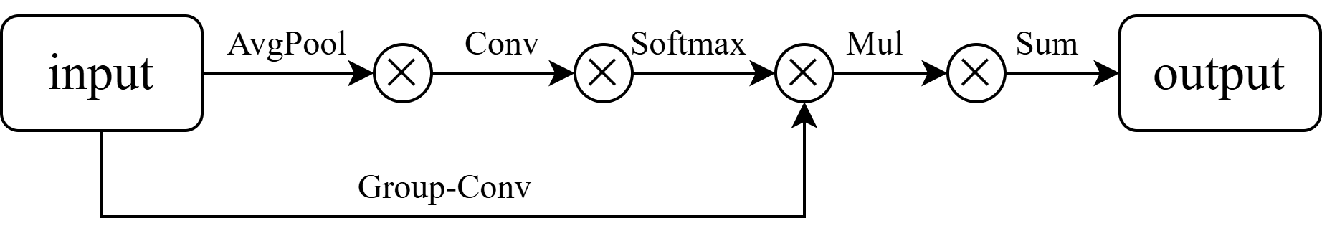
Figure 4: Structure of the LAWDS module

2.3 Dataset Construction
In this study, we use the VisDrone dataset, a widely used dataset for UAV-based small object detection tasks. The dataset includes images captured in a variety of urban and rural environments, each presenting challenges such as varying object scales, occlusions, and complex backgrounds. It is specifically designed to train and evaluate models for small object detection, which is critical in UAV-based surveillance, infrastructure monitoring, and other real-world applications.
As shown in Table 1, the VisDrone dataset comprises a total of 10,209 images, with 471,266 annotated instances across different object categories. The dataset is split into four subsets: the training set (6,471 images), validation set (548 images), test set (challenge, 1,580 images), and test set (development, 1,610 images). The training set is used to train the detection model, while the validation set is used for performance evaluation during development. The challenge test set is used for evaluating the model’s generalization to real-world scenarios, and the development test set is employed for evaluating model performance on more specialized tasks.
Table 1: The construction of dataset
Split Type | Number of Images | Description
Training Set | 6,471 | Used for training the detection model.
Validation Set | 548 | Used for model performance validation.
Test Set (Chal-lenge) | 1,580 | Used for challenge-based testing.
Test Set (Devel-opment) | 1,610 | Used for development-based testing.
Total | 10,209 | Total number of images and instances in the dataset.
The VisDrone dataset includes a variety of small and occluded objects, with a focus on real-world scenarios like traffic monitoring and urban surveillance. Given the high difficulty of detecting small targets in aerial imagery, the dataset includes both real and synthetic images, ensuring a comprehensive representation of the various defect types and environmental conditions that the model is likely to encounter.
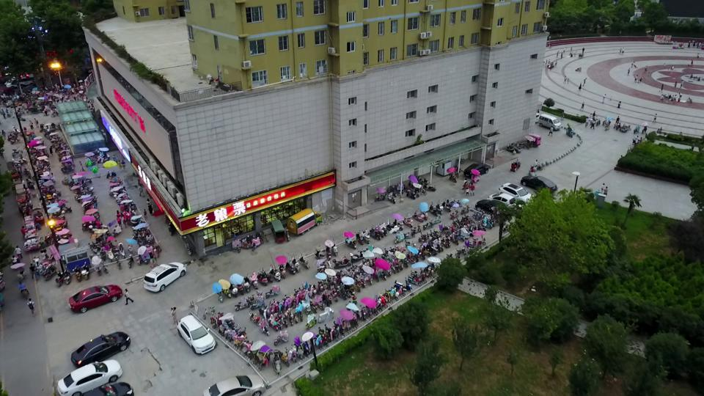 | 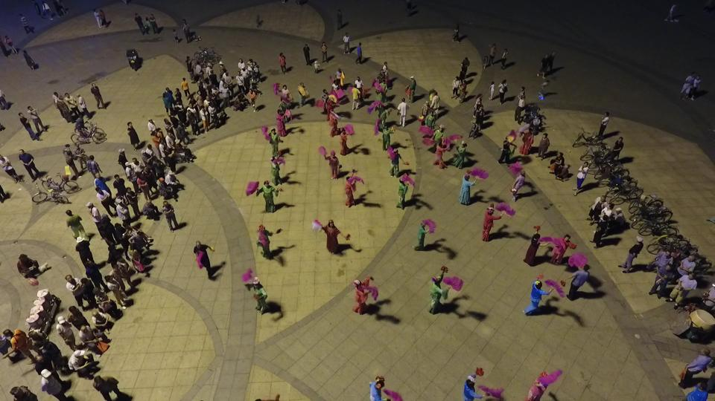 | 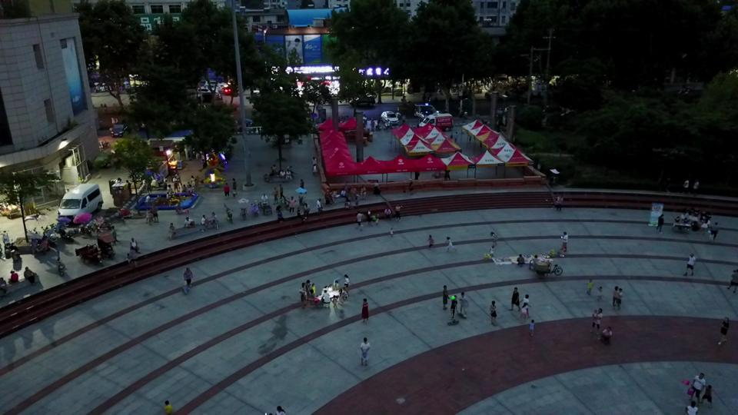
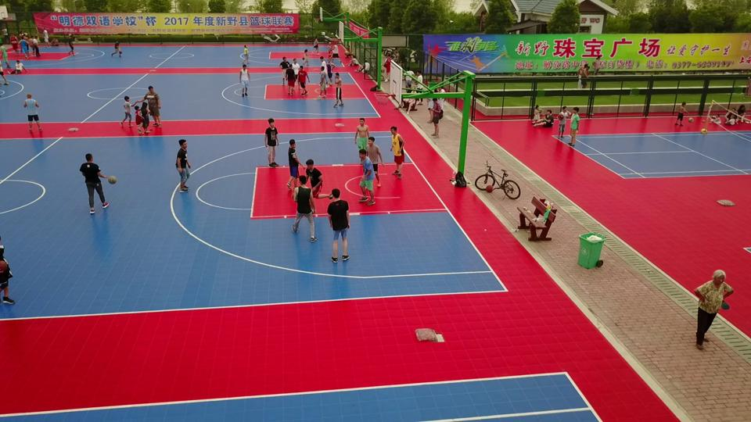 | 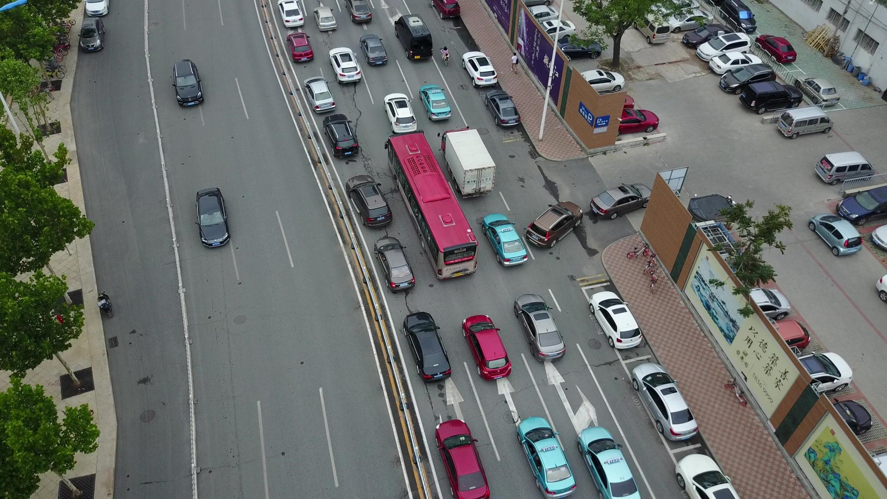 | 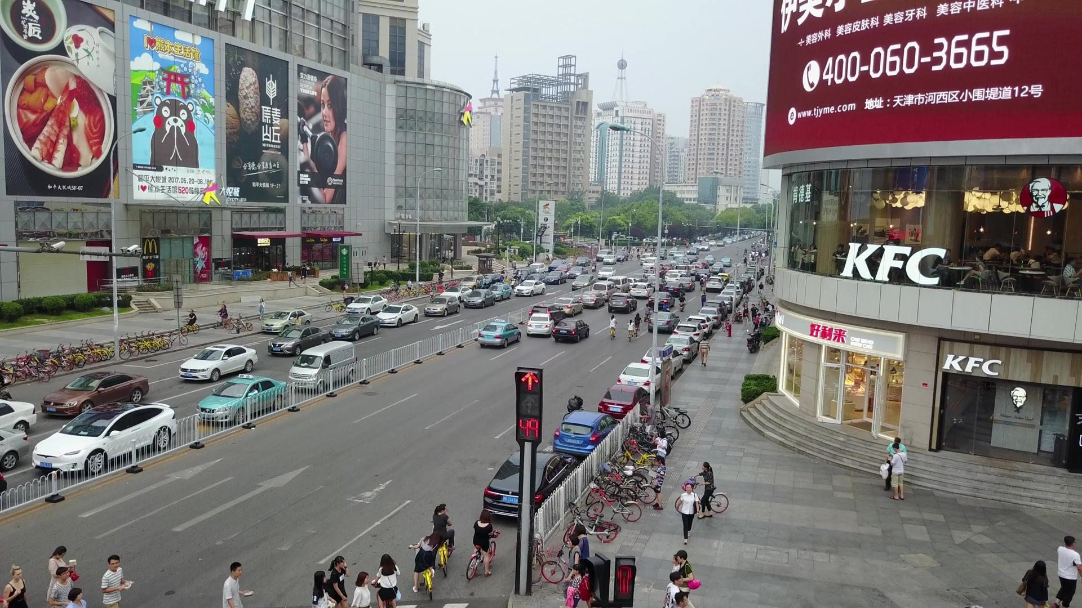
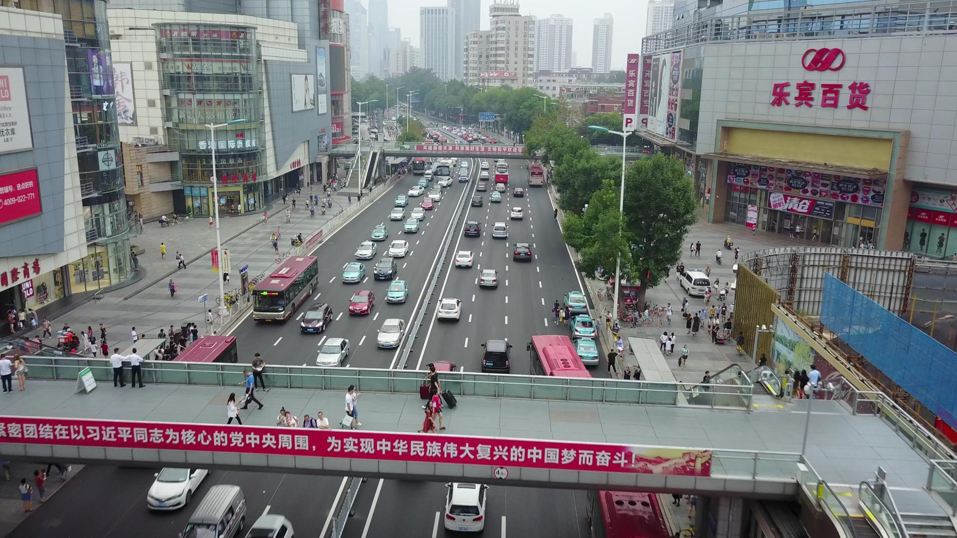 | 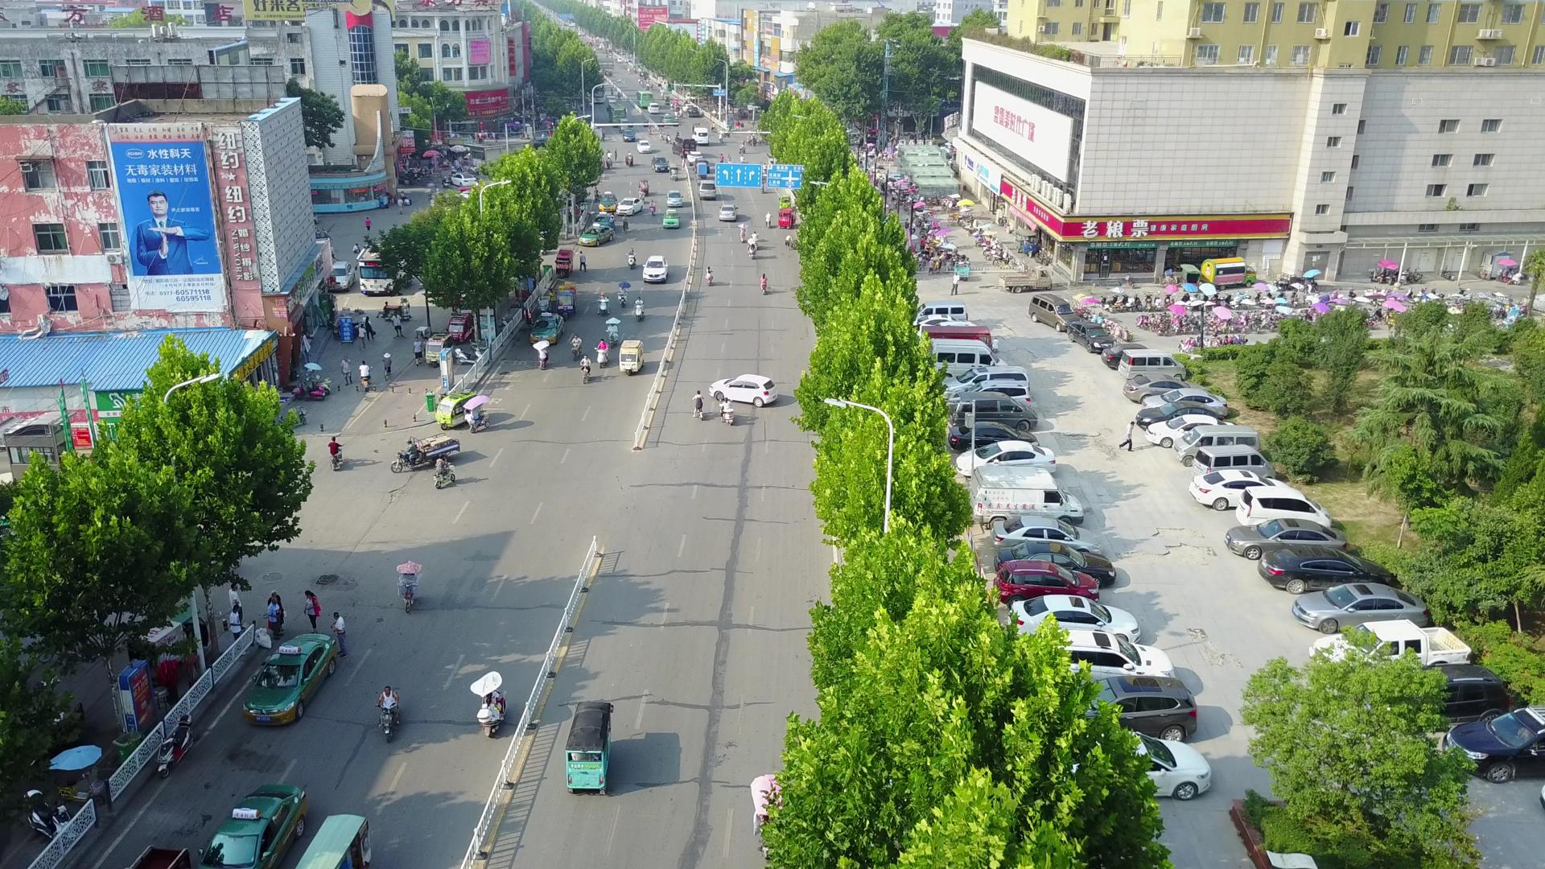 | 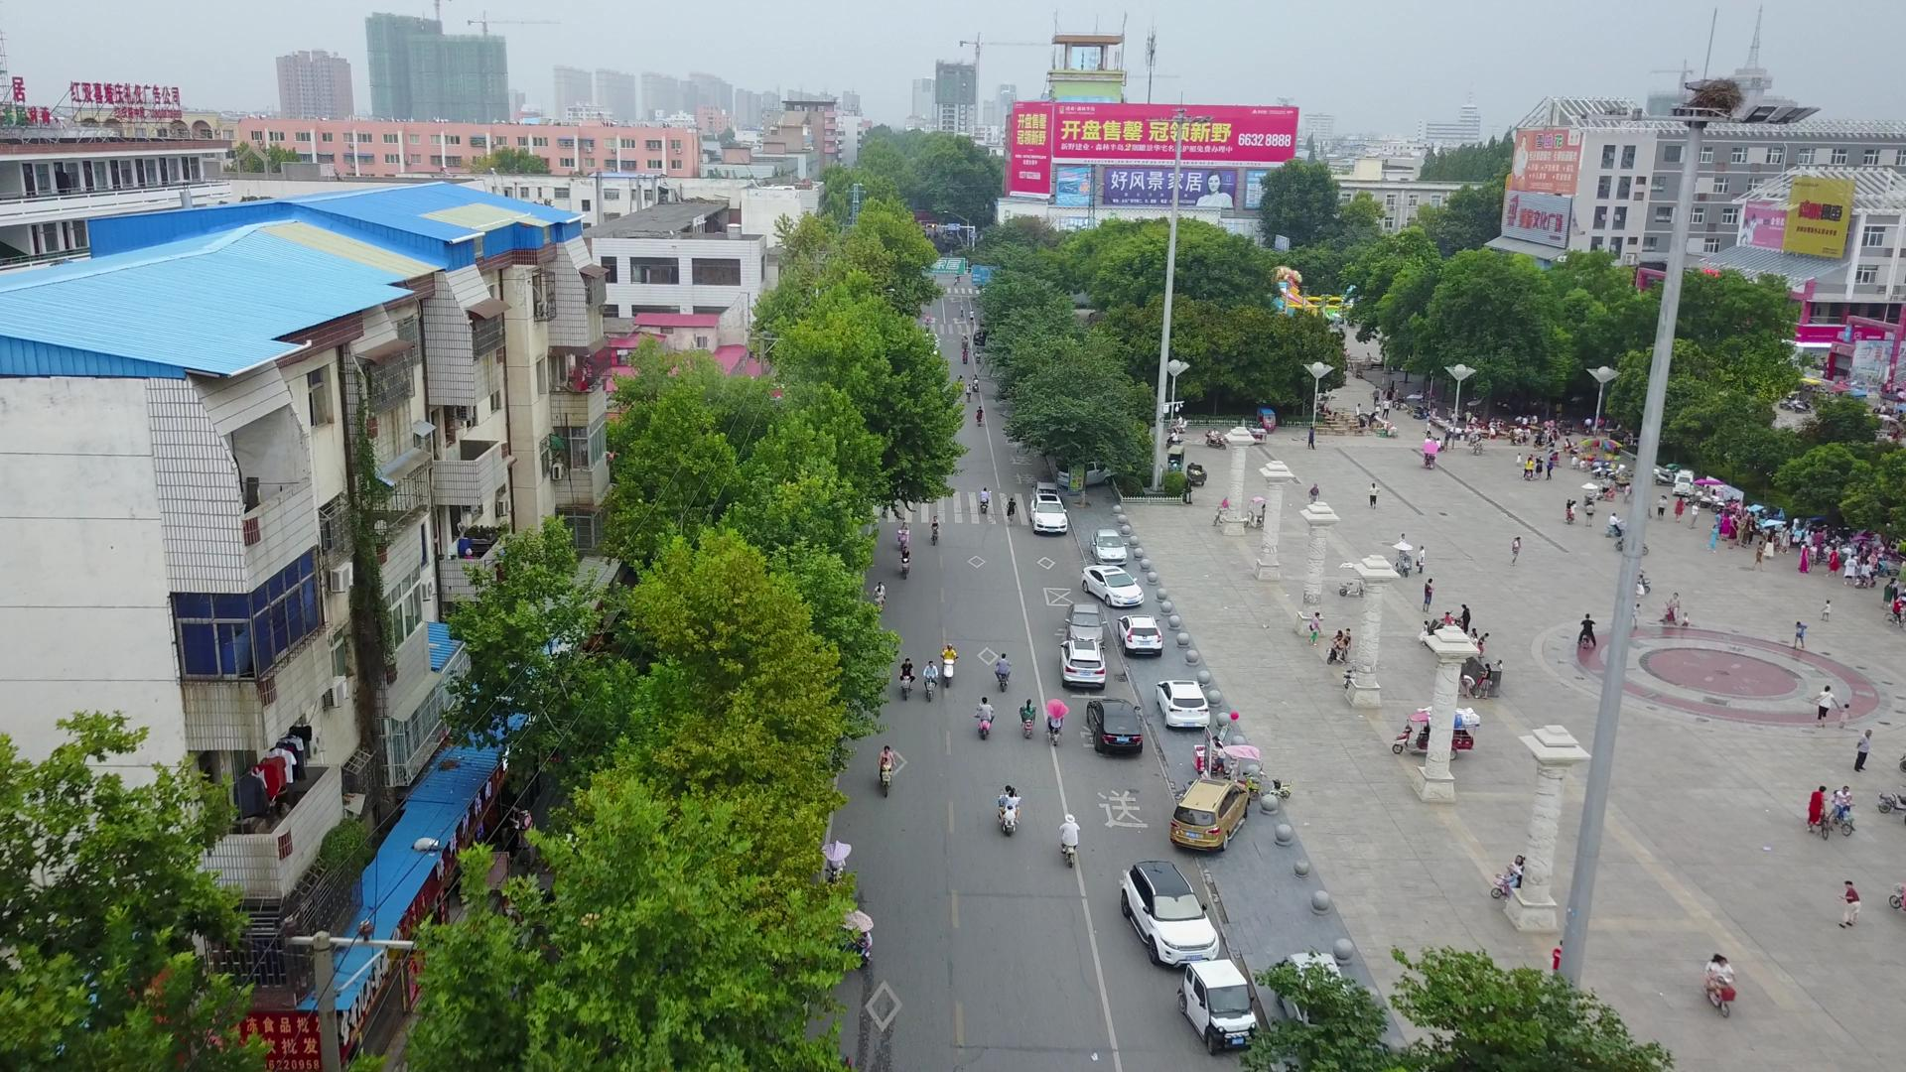
Figure 5: Example from the VisDrone dataset

3. Experimental Verification

3.1 Experimental Software and Hardware Configuration
The computational architecture proposed in this study leverages the PyTorch neural network development ecosystem. The hardware and software used in the experiment were as follows: Windows 10 operating system; Intel(R) Xeon(R) Gold 6130 CPU @ 2.10GHz; NVIDIA RTX 3090 24 G GPU; PyTorch version 2.8.0+cu126; CUDA version 12.6.

3.2 Assessment of Indicators
To comprehensively evaluate the performance of the BGL-YOLO11 model, we utilize several key metrics that measure both the detection capabilities and computational efficiency of the model. The primary evaluation indicators for this study include precision, recall, mean average precision (mAP) and F1-score. These metrics collectively assess the model’s ability to detect objects accurately, while also evaluating its efficiency and generalization in real-world settings.
Precision is one of the most important metrics used to evaluate the accuracy of object detection models. It quantifies the ratio of true positive detections to the total number of positive predictions made by the model. High precision indicates that most of the predicted positives by the model are indeed correct. $Precision$is mathematically defined as:
$$Precision=\frac{TP}{TP+FP}$$ | (4)
where$TP$refers to the number of true positives, and$FP$denotes the number of false positives.
Recall measures the proportion of actual positive samples correctly identified by the model. It reflects the model's sensitivity to detect the true positive instances and is essential when the goal is to minimize false negatives.$Recall$is given by:
$$Recall=\frac{TP}{TP+FN}$$ | (4)
where$FN$is the number of false negatives, representing the missed positive detections.
Mean average precision (mAP) is a composite metric that synthesizes the precision at various recall levels. It is particularly useful for evaluating the performance of models in tasks with multi-class detection. The calculation of mAP involves integrating the precision-recall curve for each class and averaging the results across all classes. The formula for mAP is expressed as:
$$mAP=\frac{1}{N}\sum_{i=1}^{n}{{AP}_{i}}$$ | (4)
where${AP}_{i}$is the average precision of the$i$-th class, and$N$is the total number of classes in the dataset.
The F1-score is the harmonic mean of precision and recall, providing a balanced measure between the two metrics. It is especially useful when there is an imbalance between precision and recall. The F1-score is calculated as:
$$F1=2×\frac{Precision×Recall}{Precision+Recall}$$ | (4)
A higher F1-score reflects a better trade-off between precision and recall, which is crucial when both false positives and false negatives have significant consequences.
These evaluation metrics provide a holistic view of model performance across multiple dimensions. Precision and recall individually reflect the model's ability to minimize false positives and false negatives, while mAP and F1-score help evaluate its accuracy and robustness in multi-class scenarios. These indicators help assess the trade-offs between detection performance, computational complexity, and real-world application requirements.

3.3 Training and Prediction of BGL-YOLO11
For training the improved BGL-YOLO11 model, we used the VisDrone dataset, which presents a variety of challenges typical for UAV-based applications, such as varying object scales, occlusions, and complex backgrounds. The training process was conducted with a batch size of 32, an image size of 640 pixels, and set to 150 epochs. The hyperparameters for training were carefully chosen, as shown in Table 2.

Table 2: Hyperparameter settings
Hyperparameter | Value | Description
Batch Size | 32 | The number of images processed in one iteration.
Image Size | 640 | The input size of images fed into the network.
Epochs | 150 | The number of full passes through the dataset.
Optimizer | SGD | The optimizer used for training, specifically Stochastic Gradient Descent.
Learning Rate | 0.01 | The rate at which the model’s weights are updated during training.
Momentum | 0.937 | Momentum used in the optimizer to accelerate convergence.
Weight Decay | 0.0005 | Regularization to prevent overfitting by penalizing large weights.
Warmup Epochs | 3 | Number of epochs during which the learning rate increases gradually.
Conf. Threshold | 0.5 | Confidence threshold for considering predictions valid.
IOU Threshold | 0.7 | Threshold for non-maximum suppression (NMS).
The training results are illustrated in Figure 11, where we can observe a clear reduction in both training and validation losses as the number of epochs increased. The model's convergence is visible from the rapid decline in loss during the initial epochs, followed by stabilization, confirming the model's robustness in handling the dataset. Along with the loss curves, metrics such as precision, recall, mAP50, and mAP50-95 were monitored throughout the training to ensure optimal performance. These metrics are shown in the additional graphs, reflecting the steady improvements in detection accuracy.
The confusion matrix (Figure 6) provides a detailed view of how well the model distinguished between different classes. The model performed exceptionally well in detecting categories such as "car," "pedestrian," and "bicycle." However, there were some challenges with categories that are less frequent in the dataset, like "bus" and "awning-tricycle," where some false positives were observed.
The Precision-Recall curve (Figure 9) reveals that the model achieves high precision across most classes, with a noticeable improvement in precision for high-confidence predictions, while maintaining a balanced recall. Meanwhile, the Recall-Confidence curve (Figure 10) shows the model’s performance in terms of recall at varying confidence thresholds. As expected, recall improves with lower confidence levels but at the expense of precision, which is typical when detecting small or occluded objects in cluttered backgrounds.
Figure 12 showcases the effectiveness of the BGL-YOLO11 model in predicting object classes across various images from the VisDrone dataset. Each image displays the model’s detection results with bounding boxes and confidence scores, demonstrating its ability to accurately identify objects even in complex, cluttered environments with varying object scales and occlusions. The high confidence scores further validate the model's robustness in real-world applications.
The evaluation results, based on the metrics, consistently showed that the improved model achieved superior performance compared to previous methods. This demonstrates the model's robustness in real-world scenarios, particularly in complex UAV-based environments where small, occluded objects are often difficult to detect.
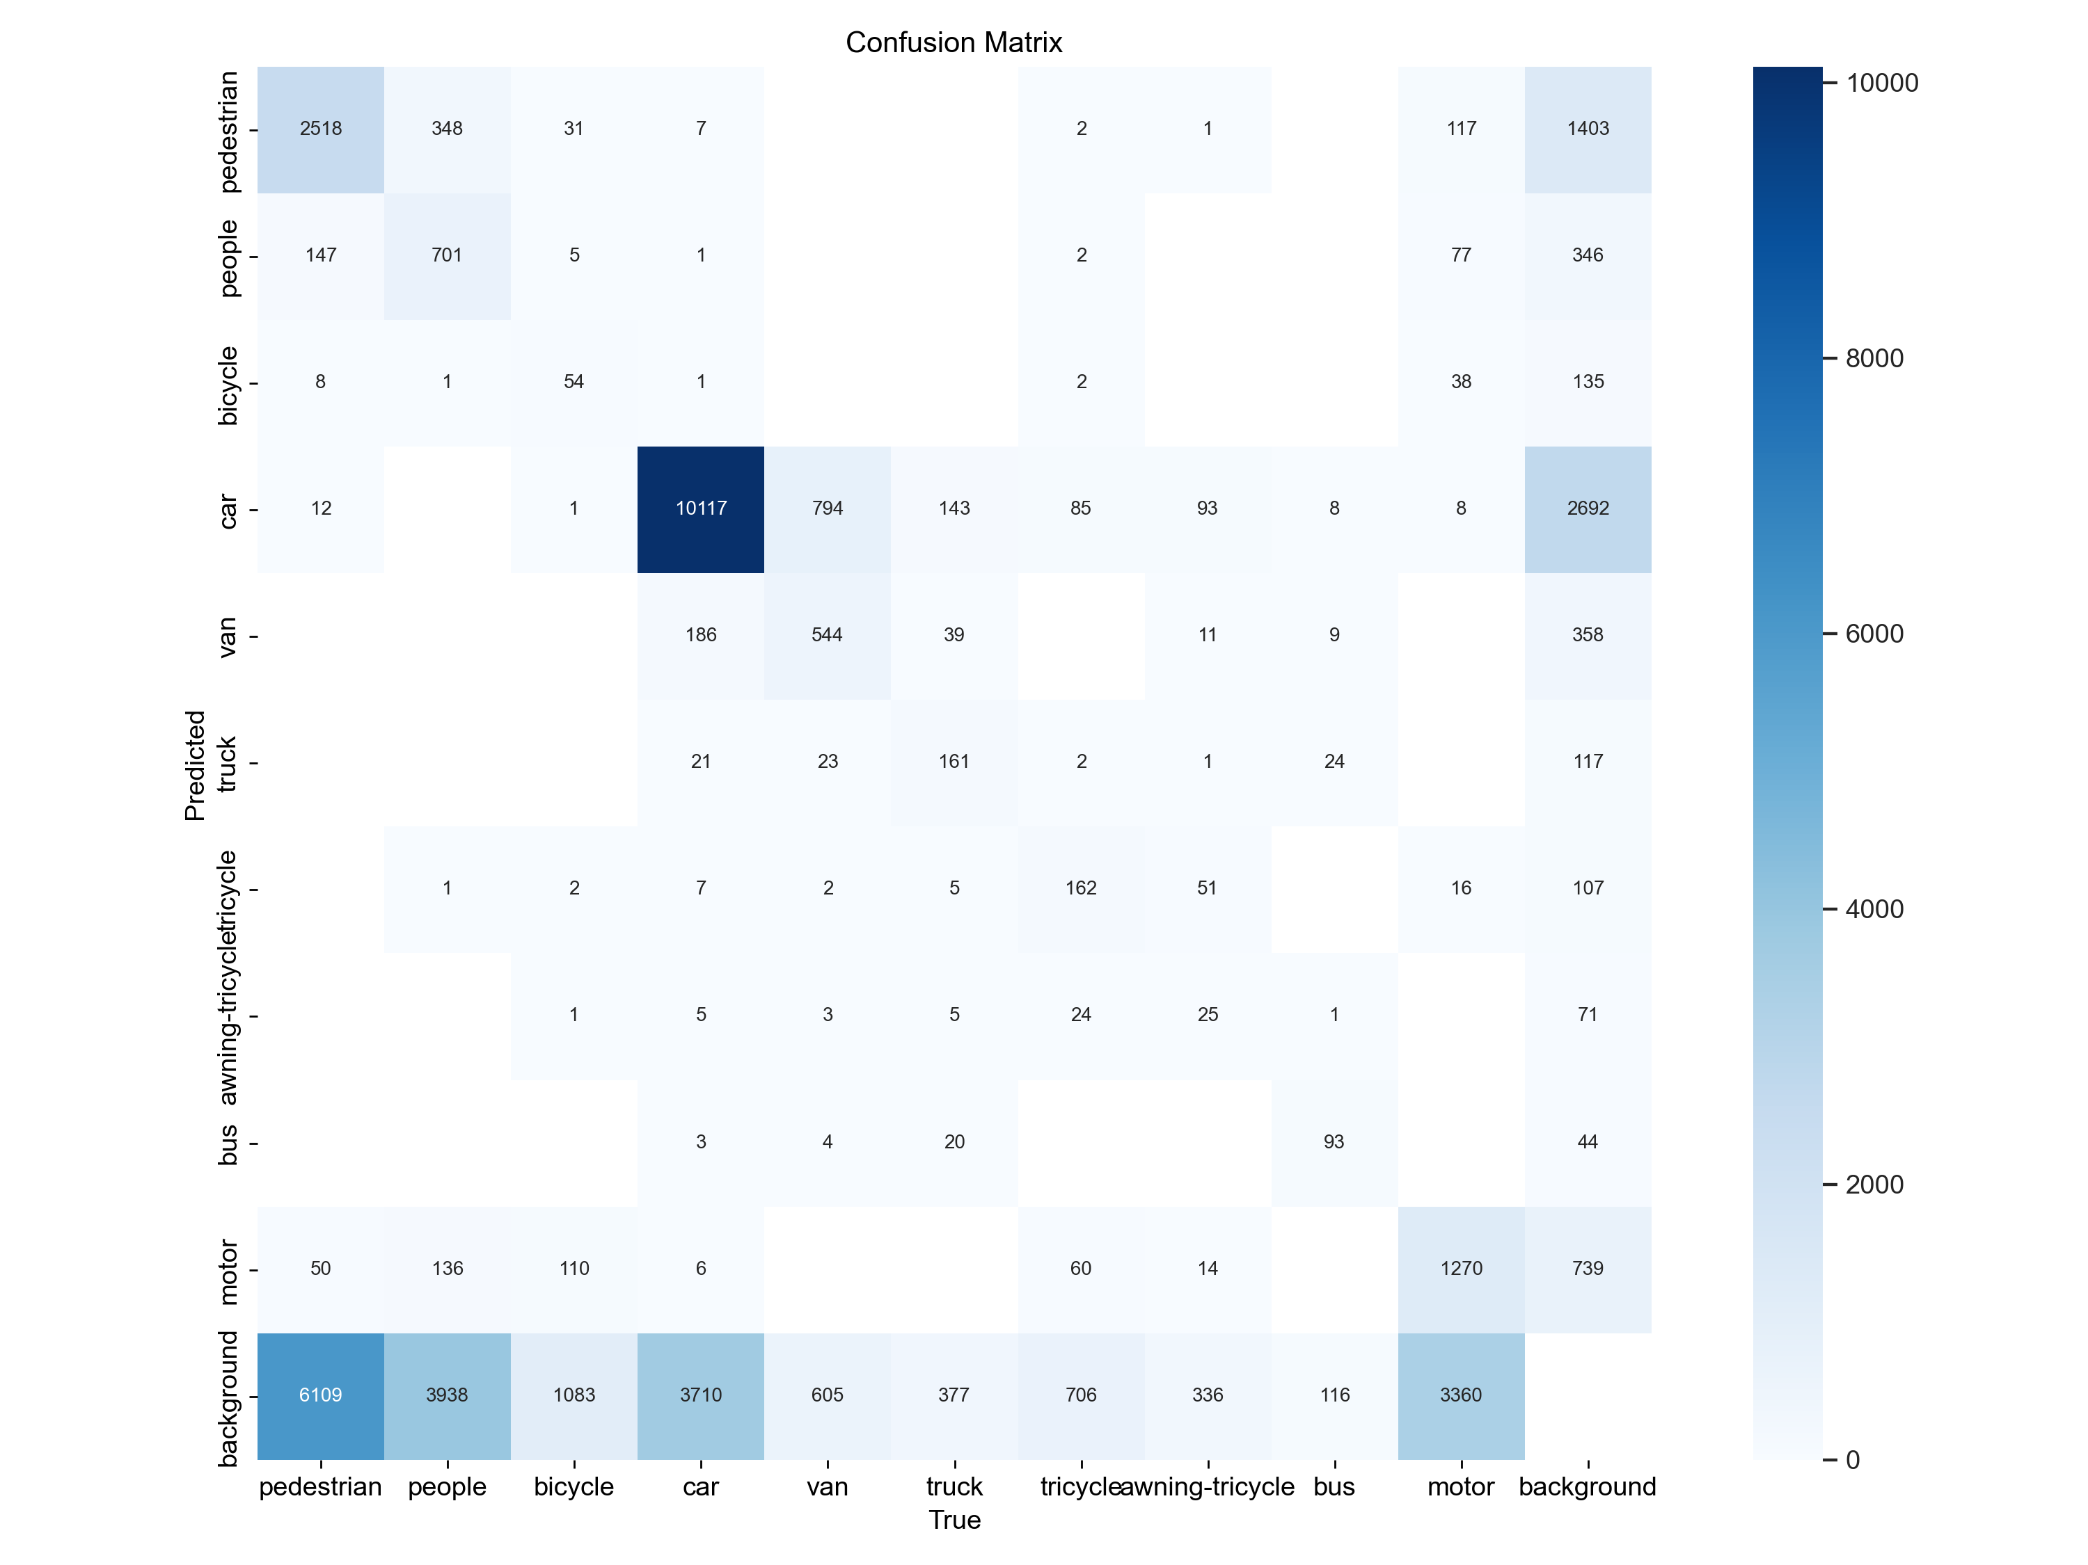
Figure 6: The confusion matrix of the BGL-YOLO11
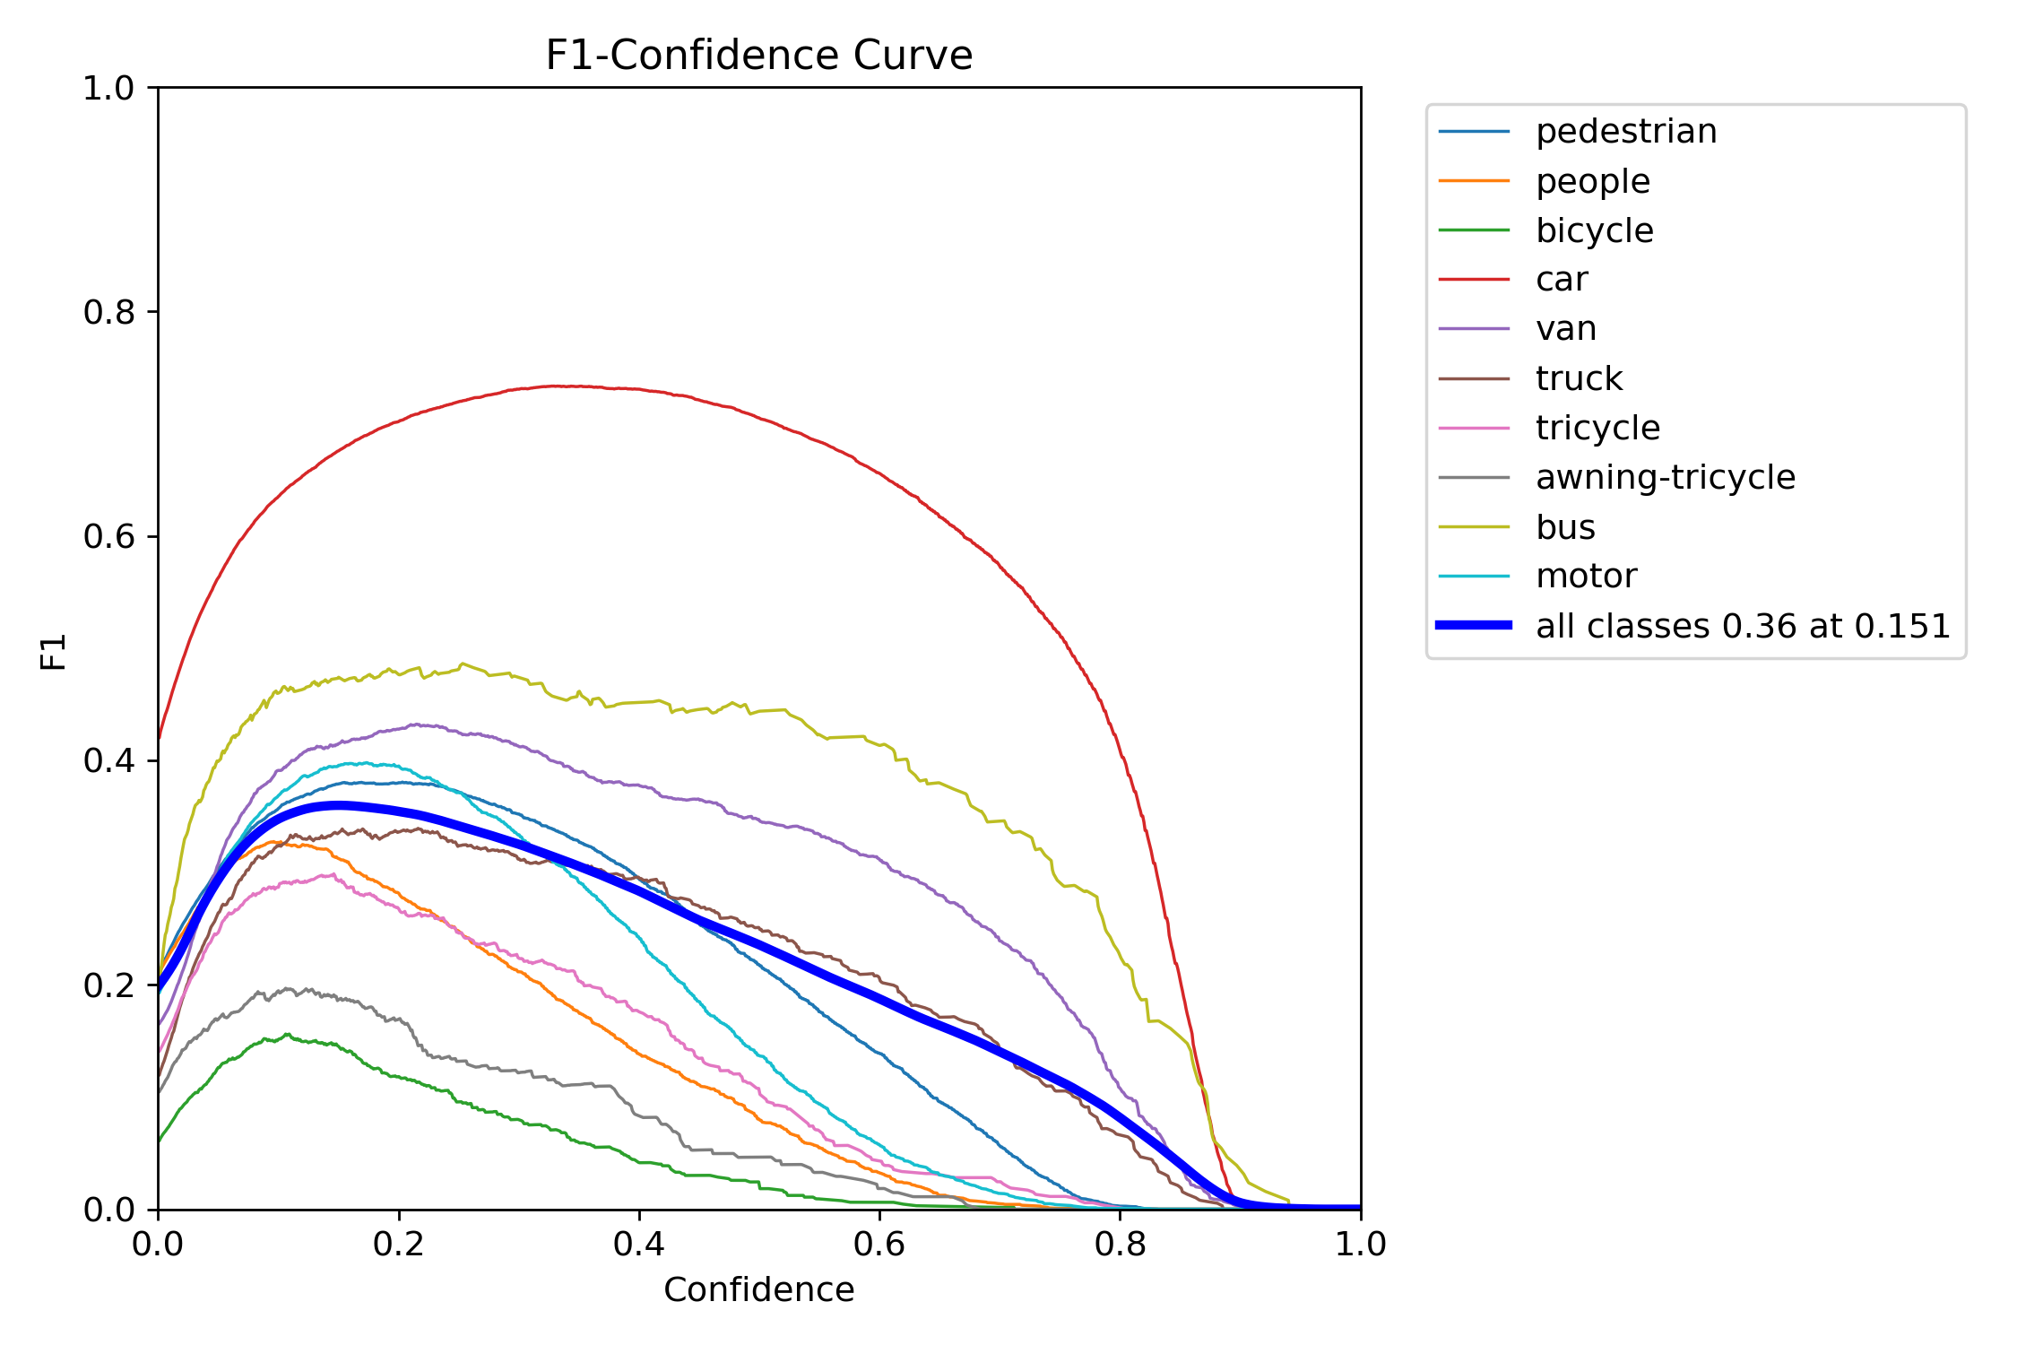
Figure 7: The F1-Confidence Curve of the BGL-YOLO11
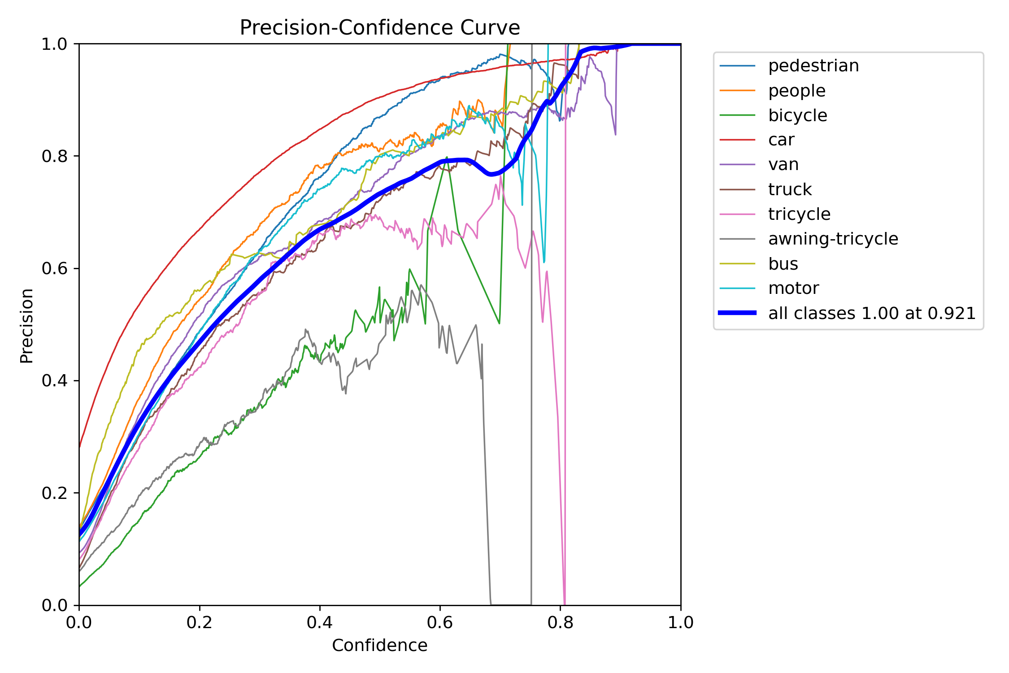
Figure 8: The Precision-Confidence Curve of the BGL-YOLO11
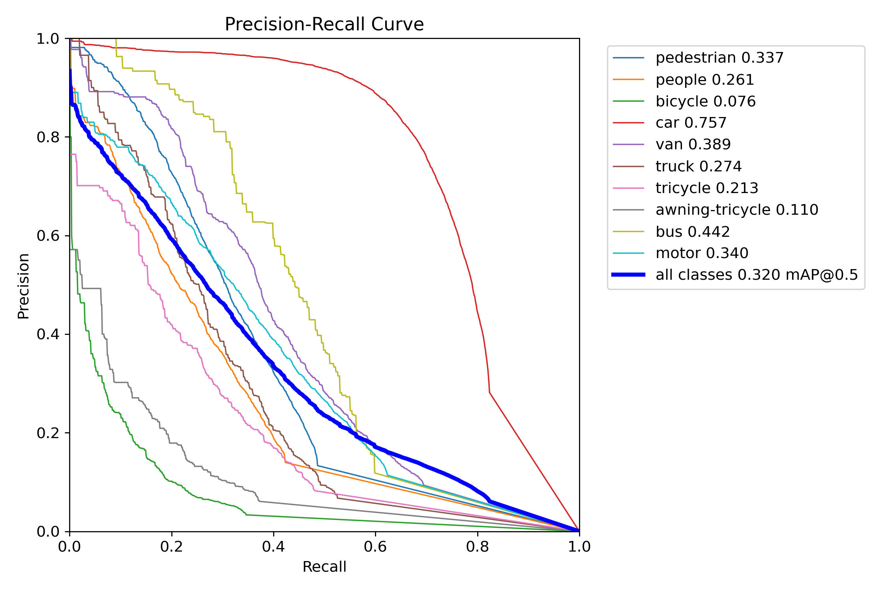
Figure 9: The Precision-Recall Curve of the BGL-YOLO11
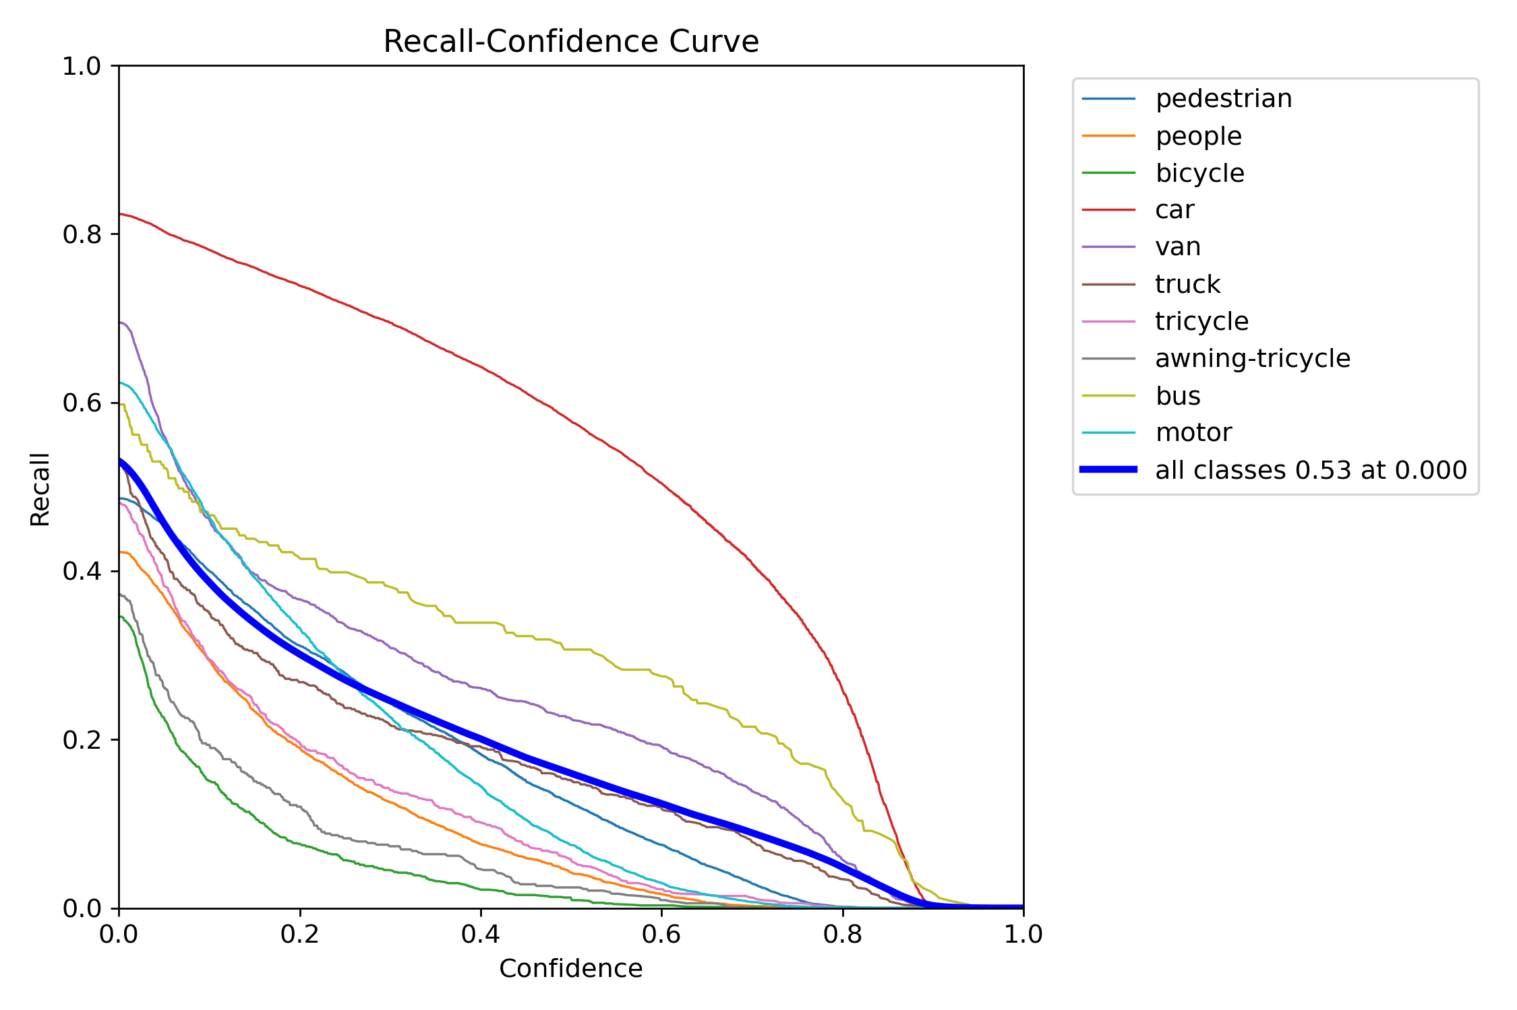
Figure 10: The Recall-Confidence Curve of the BGL-YOLO11
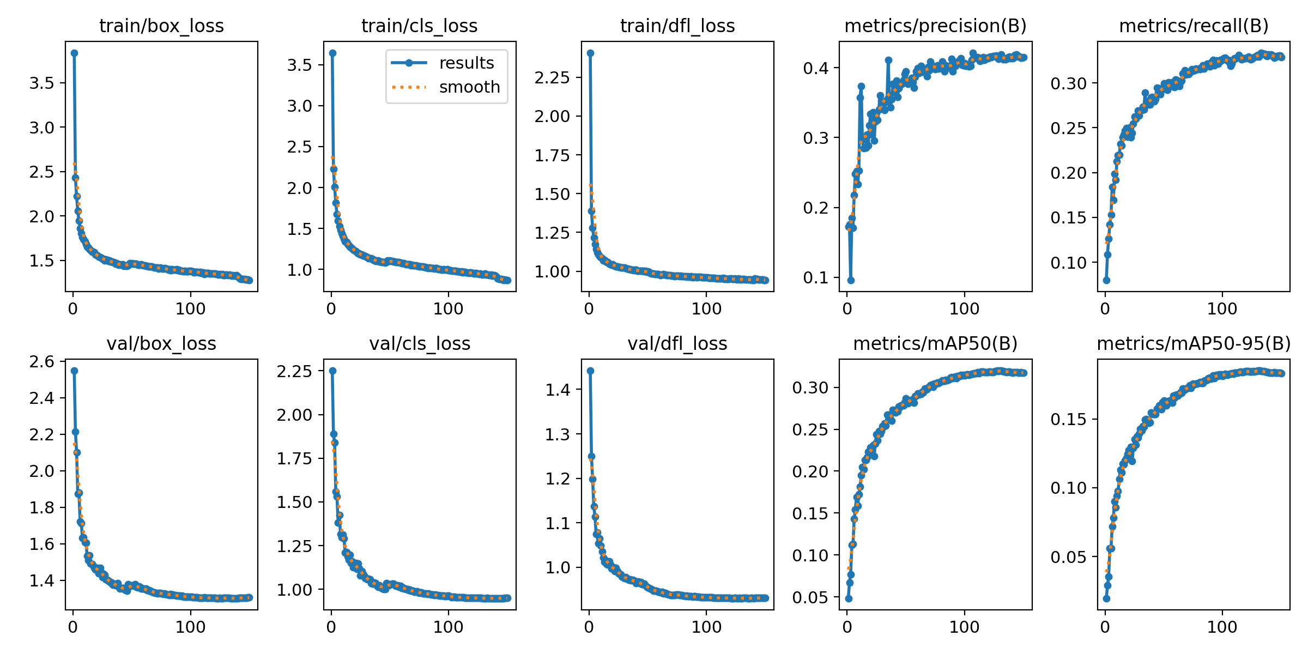
Figure 11: Training and validation loss curves and evaluation metrics during training
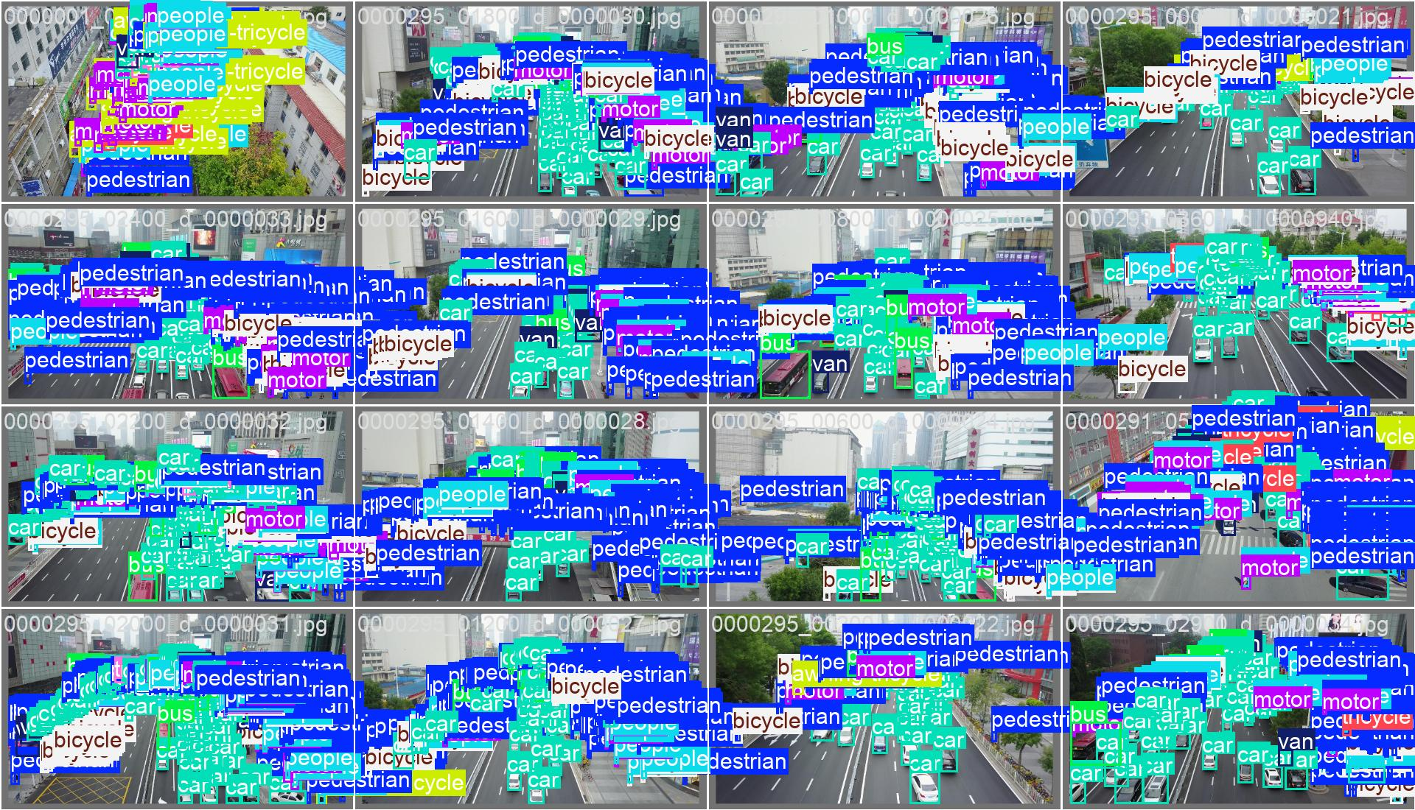 | 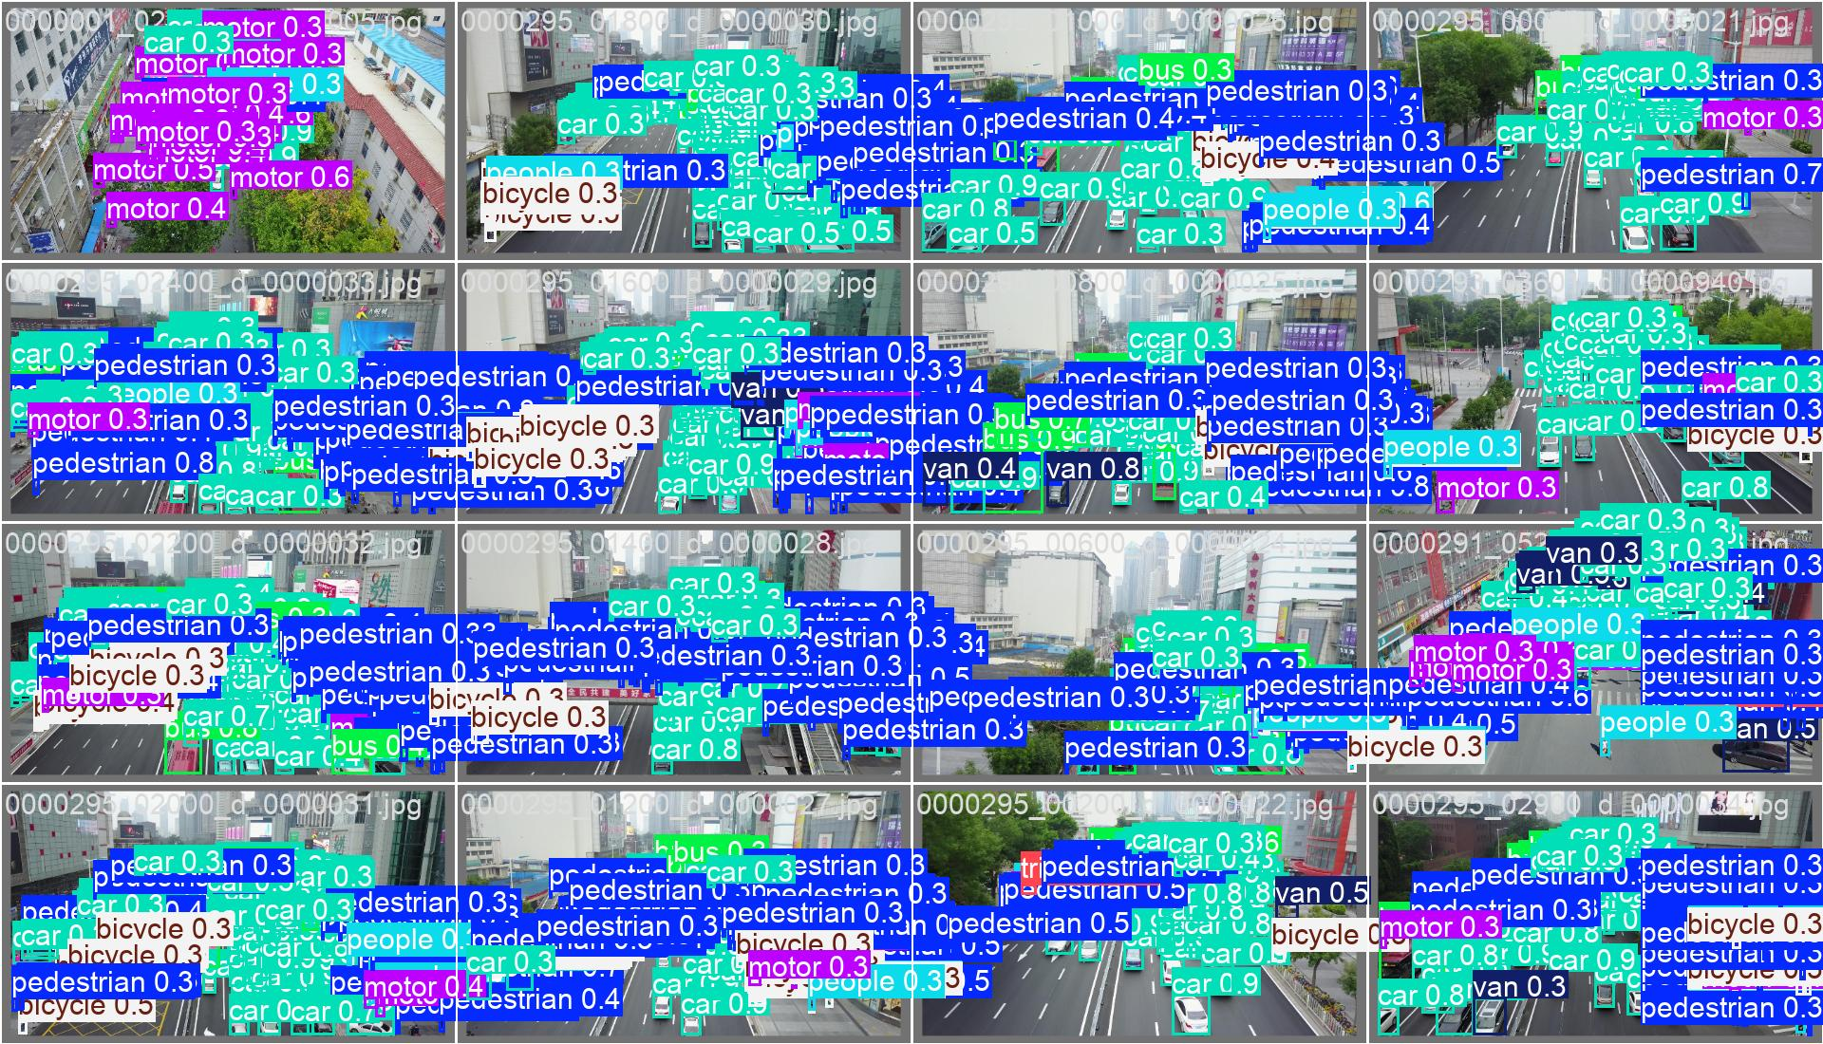
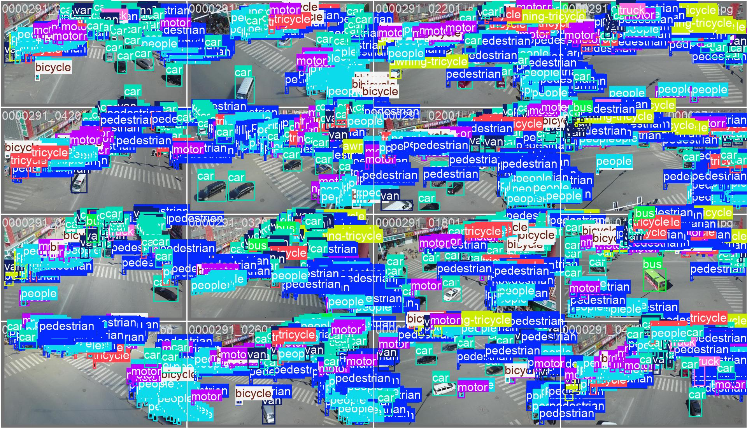 | 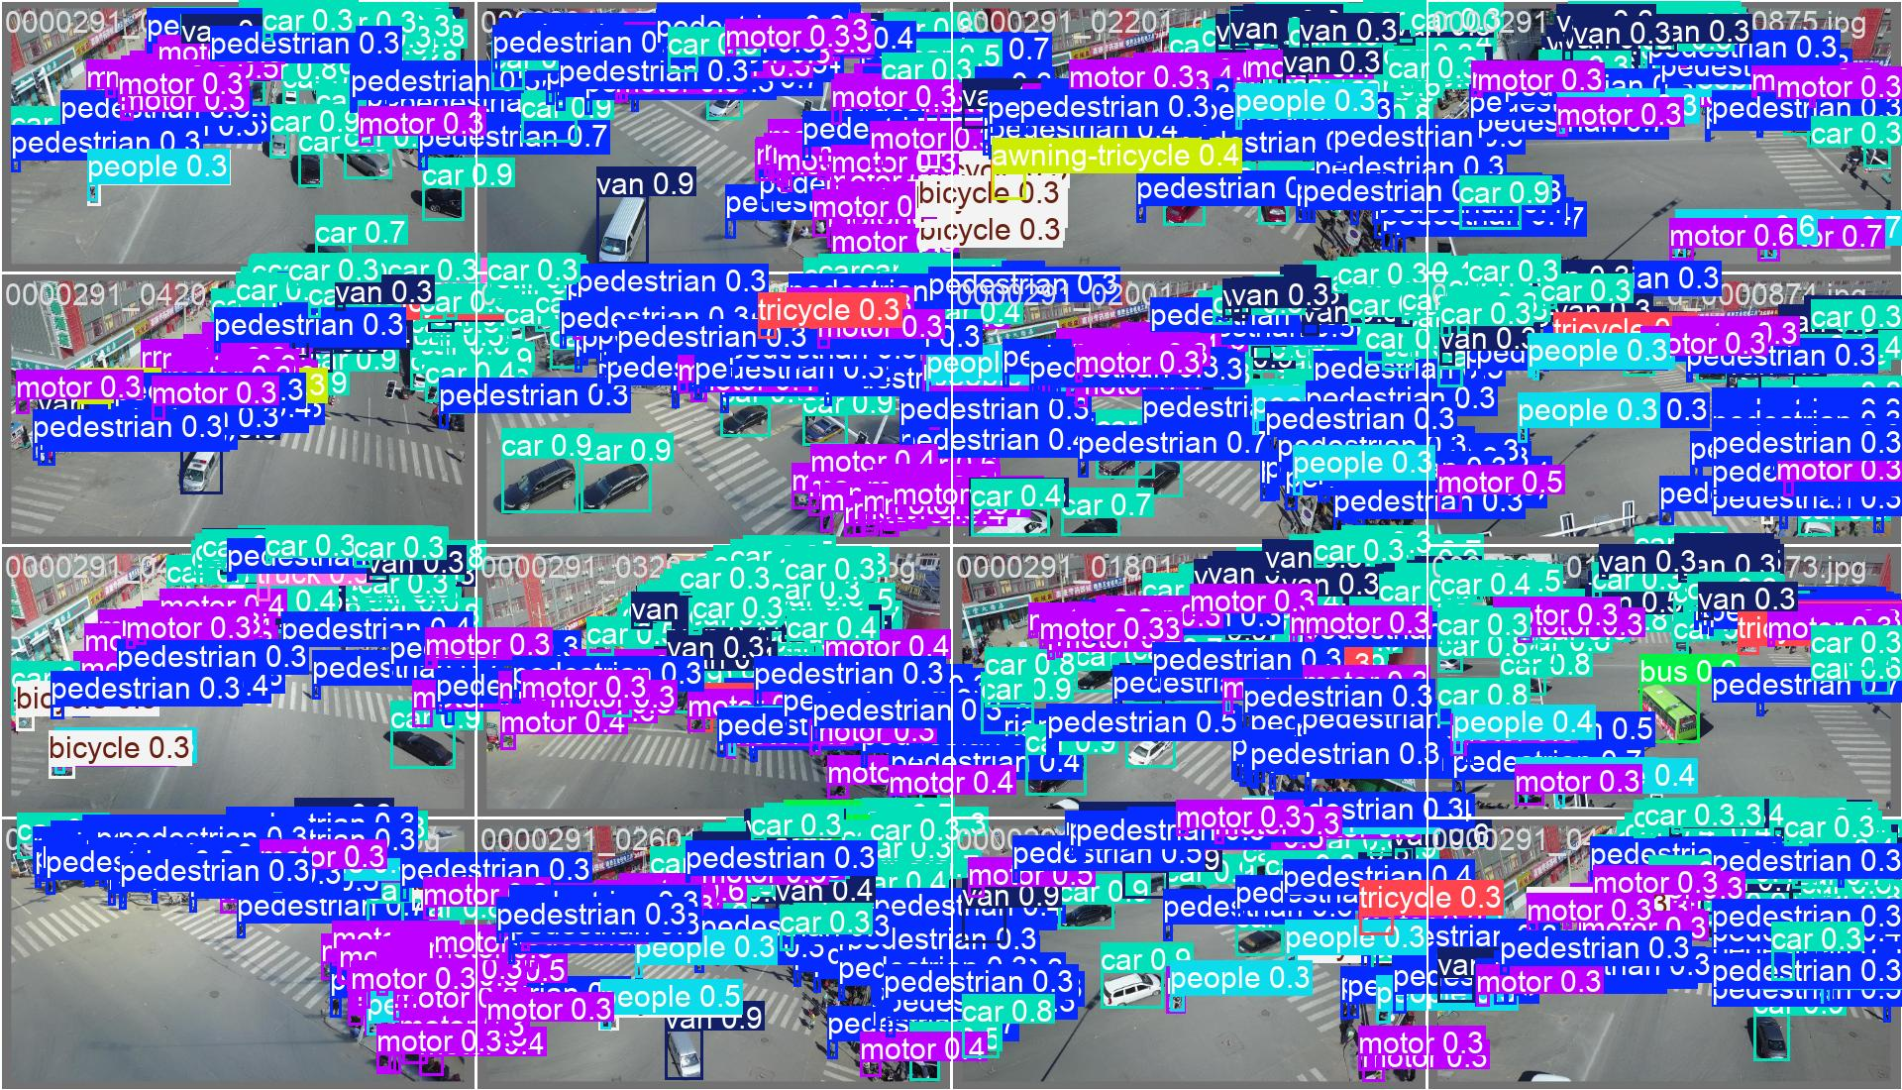
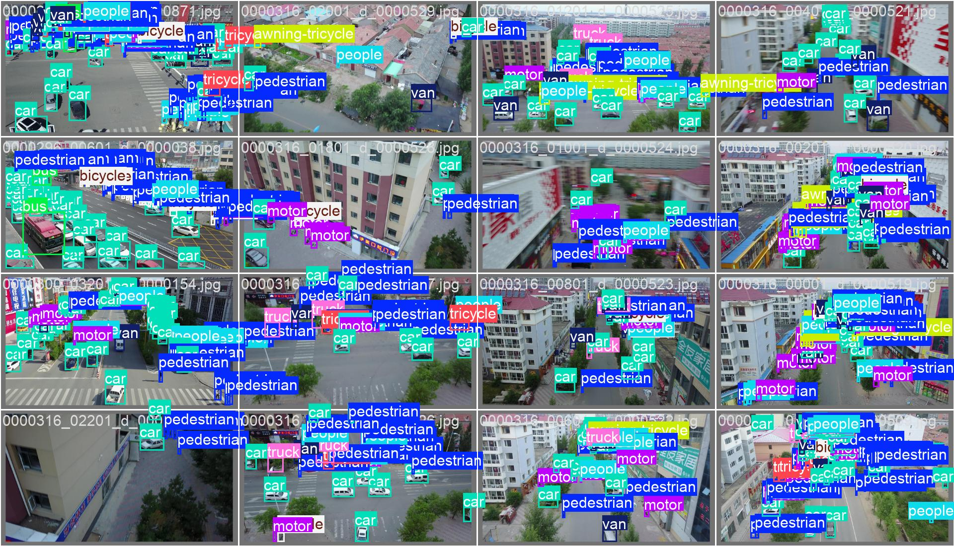 | 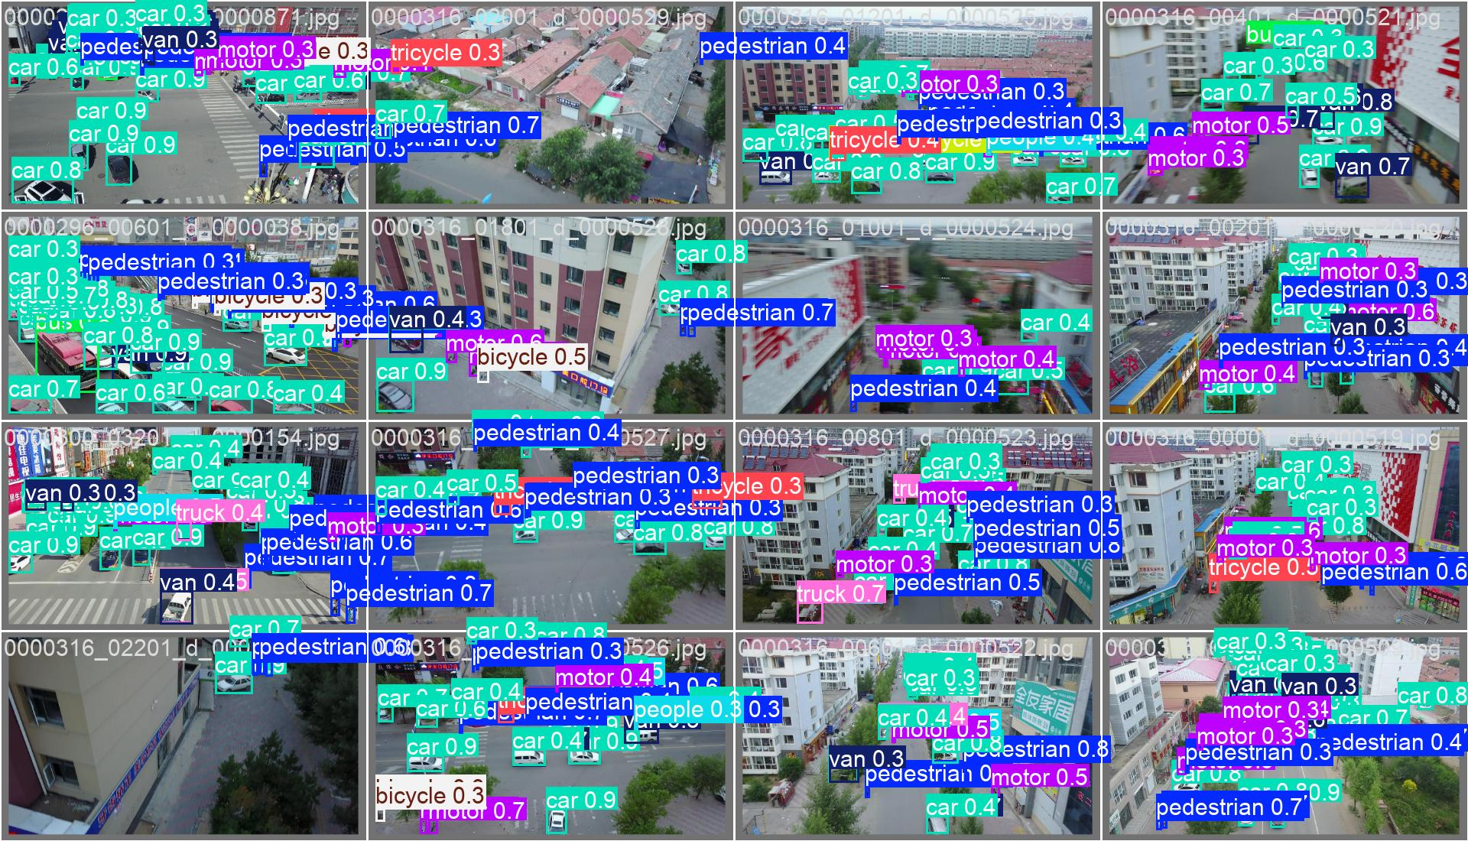
Figure 12: The effectiveness of dataset prediction results

3.4 Comparative Experiments
To evaluate the performance of the BGL-YOLO11 model, we compare it with several other popular YOLO-based models across multiple metrics. Table 3 presents the key performance indicators for each model, including the number of parameters (Params/M), GFLOPs (floating-point operations per second), model size, precision, and mAP scores at different thresholds (mAP50 and mAP50-95).
From the table, it is clear that BGL-YOLO11 achieves the highest precision among all models, with 44.70%, outperforming other models like YOLOv5nu, YOLOv6n, and YOLOv8n. In terms of mAP50 and mAP50-95, BGL-YOLO11 also shows competitive performance, indicating that it provides a good balance between model size and detection accuracy. The model’s relatively compact size of 4.3MB, coupled with its efficiency, further demonstrates its suitability for real-time deployment in UAV-based applications, where resource constraints are often a concern.
Table 3: Performance comparison between various YOLO-based models
Model | Params/M | GFLOPs | Model Size | Precision | mAP50 | mAP50-95
YOLOv5nu | 2.18 | 5.8 | 4.4MB | 36.43% | 27.57% | 16.01%
YOLOv6n | 4.16 | 11.5 | 8.1MB | 37.17% | 28.65% | 16.49%
YOLOv8n | 2.69 | 6.8 | 5.4MB | 41.70% | 32.72% | 19.70%
YOLOv9t | 1.73 | 6.4 | 4.0MB | 41.32% | 32.30% | 19.16%
YOLOv10n | 2.27 | 6.5 | 5.5MB | 42.13% | 33.21% | 19.29%
BGL-YOLO11 | 2.07 | 6.7 | 4.3MB | 44.70% | 33.93% | 19.74%

3.5 Ablation Experiments
This section presents the ablation experiments designed to evaluate the contribution of each component integrated into the BGL-YOLO11 model. Table 4 summarizes the models tested with different configurations of attention mechanisms, such as BiFPN, GLSA, and LAWDS. The table indicates the presence or absence of these components in each model.
These ablation studies aim to understand the individual impact of each attention mechanism on the overall performance. For example, models incorporating BiFPN, GLSA, and LAWDS were individually tested to assess their independent contributions to the model’s precision and mAP metrics. The results help us identify how each component enhances the ability of BGL-YOLO11 to perform small object detection in complex scenarios.
Table 4: Ablation study configuration overview
Model | BiFPN | GLSA | LAWDS
Baseline | - | - | -
M1 | √ | - | -
M2 | - | √ | -
M3 | - | - | √
M4 | √ | √ | -
M5 | - | √ | √
M6 | √ | - | √
BGL-YOLO11 | √ | √ | √
In Table 5, we present a detailed comparison of model performance, focusing on parameters, GFLOPs, model size, and key evaluation metrics like Precision, mAP50, and mAP50-95. This table shows the parameters and performance metrics for different models tested in the ablation experiments. The results reveal how the addition of different attention mechanisms (BiFPN, GLSA, and LAWDS) influences the model's computational efficiency and detection accuracy. For example, the baseline model has lower precision and mAP scores compared to the models incorporating these attention mechanisms, demonstrating their significant role in improving performance.
Table 4: Performance comparison of various model configurations
Model | Params/M | GFLOPs | Model Size | Precision | mAP50 | mAP50-95
Baseline | 1.78 | 6.8 | 3.8MB | 41.49% | 32.00% | 18.56%
M1 | 3.45 | 8.6 | 7.0MB | 43.05% | 32.86% | 19.06%
M2 | 3.74 | 8.6 | 7.5MB | 42.53% | 32.46% | 18.73%
M3 | 1.63 | 6.3 | 3.4MB | 43.16% | 32.43% | 18.84%
M4 | 1.92 | 6.3 | 4.0MB | 43.33% | 32.95% | 19.24%
M5 | 2.58 | 6.3 | 5.2MB | 44.49% | 34.01% | 19.83%
M6 | 2.24 | 6.4 | 4.6MB | 43.69% | 33.10% | 19.33%
BGL-YOLO11 | 2.07 | 6.7 | 4.3MB | 44.70% | 33.93% | 19.74%

4 Discussion

4.1 Practical Significance
In this study, we presented an improved model, BGL-YOLO11, for the detection of small and occluded objects in UAV-based aerial imagery, specifically applied to infrastructure monitoring. The model's enhanced accuracy, particularly with small targets, presents practical benefits for real-time deployment in drone inspection tasks. While the model's performance improvement may seem modest (1.4%), it could lead to significant operational advantages when applied to large-scale real-world inspections, such as reducing false positives and minimizing detection time in vast power grid infrastructure. Additionally, the ability to detect defects reliably could prevent catastrophic failures in critical infrastructure, offering a valuable economic and safety advantage.

4.2 Practical Deployment and Real-Time Analysis
The findings from this study suggest that the BGL-YOLO11 model can be deployed in real-world scenarios where real-time processing and high accuracy are critical. The integration of modules like BiFPN, GLSA, and LAWDS improved the model's ability to process small and occluded objects without significantly increasing computational overhead, making it suitable for deployment on UAVs with resource constraints. Furthermore, the model demonstrated robustness across varying environmental conditions, which is essential for UAV-based applications. Future work should focus on optimizing the model's performance in more challenging environments, considering factors such as real-time edge processing and hardware adaptation for large-scale deployments.

4.2 Future Work
To overcome the current limitations, future research will focus on expanding the dataset to include a wider range of real-world conditions, such as different weather and lighting conditions, as well as testing the model in diverse geographic regions. Additionally, improving the model's ability to handle complex multi-object scenarios, especially with occlusions, will be a key research direction. Finally, the integration of real-time adaptation techniques for edge deployment will enhance the practical utility of BGL-YOLO11 in dynamic environments.

5 Conclusions
This paper presented an advanced object detection model, BGL-YOLO11, for UAV-based small object detection in complex, cluttered environments. The model’s integration of BiFPN, GLSA, and LAWDS demonstrated its ability to effectively detect small, occluded objects in real-time without compromising computational efficiency. The experimental results showed that BGL-YOLO11 achieved higher precision and mAP compared to previous YOLO models, marking significant advancements in UAV-based object detection tasks. The model's accuracy (mAP@0.5) improved by 1.4%, offering a compelling solution for real-time infrastructure inspection tasks where small target detection is critical.
The model's lightweight design and robustness against complex backgrounds position it well for practical deployment in resource-constrained UAV systems. Furthermore, the incorporation of synthetic data enhanced model performance while addressing domain biases. Future work will focus on refining the model for real-time deployment, expanding the dataset to improve generalization, and addressing the challenge of multi-target detection in dynamic scenarios.
Acknowledgement: Not applicable.
Funding Statement: This research was funded by Teaching Quality and Teaching Reform Project of Undergraduate Colleges and Universities in Guangdong Province, Guangdong Education Higher Letter [2021] No.29, Shaoguan University 22nd Batch of Educational Teaching Reform Projects, SYJY20211103, Shaoguan University Curriculum Civics Programme, Shao College Office [2022] No. 5 and Shaoguan support programme for researchers, 220607154531465.
Author Contributions: The authors confirm contribution to the paper as follows: Conceptualization, D.P., H.Y., and H.J.; methodology, D.P.; software, D.P.; validation, D.P., H.Y., and H.J.; formal analysis, D.P.; investigation, H.Y. and H.J.; resources, H.Y.; data curation, H.Y.; writing—original draft preparation, D.P., H.Y., and H.J.; writing—review and editing, D.P., H.Y., and H.J.; visualization, H.Y. and H.J.; supervision, H.Y.; project administration, D.P.; funding acquisition, D.P. All authors have read and agreed to the published version of the manuscript.
Availability of Data and Materials: Not applicable.
Ethics Approval: Not applicable.
Conflicts of Interest: The authors declare no conflicts of interest to report regarding the present study.

References
1. Tang G, Ni J, Zhao Y, Gu Y, Cao W. A survey of object detection for UAVs based on deep learning. Remote Sensing. 2023;16(1):149.
2. Xu B, Cai D, Sui K, Wang Z, Liu C, Pei X. MBD-YOLO: An Improved Lightweight Multi-Scale Small-Object Detection Model for UAVs Based on YOLOv8. Applied Sciences. 2025;15(20):10877.
3. Yao B, Zhang C, Meng Q, Sun X, Hu X, Wang L, et al. SRM-YOLO for Small Object Detection in Remote Sensing Images. Remote Sensing. 2025;17(12):2099.
4. Zhong H, Zhang Y, Shi Z, Zhang Y, Zhao L. PS-YOLO: A Lighter and Faster Network for UAV Object Detection. Remote Sensing. 2025;17(9):1641.
5. Tan L, Zhang C, Bai H, Liu Z, Li Y. A real-time and efficient detector for small object in UAV aerial images. Scientific Reports. 2025;15(1):39233.
6. Weng S, Wang H, Wang J, Xu C, Zhang E. YOLO-SRMX: A Lightweight Model for Real-Time Object Detection on Unmanned Aerial Vehicles. Remote Sensing. 2025;17(13):2313.
7. Zhou H, Xu C, Tang X, Wang S, Zhang Z. A review of vision-laser-based civil infrastructure inspection and monitoring. Sensors. 2022;22(15):5882.
8. Nikouei M, Baroutian B, Nabavi S, Taraghi F, Aghaei A, Sajedi A, et al. Small Object Detection: A Comprehensive Survey on Challenges, Techniques and Real-World Applications. arXiv preprint arXiv:250320516. 2025.
9. Yao G, Zhu S, Zhang L, Qi M. Hp-yolov8: high-precision small object detection algorithm for remote sensing images. Sensors. 2024;24(15):4858.
10. Li C, Luo B, Hong H, Su X, Wang Y, Liu J, et al. Object detection based on global-local saliency constraint in aerial images. Remote Sensing. 2020;12(9):1435.
11. Meimetis D, Daramouskas I, Patrinopoulou N, Lappas V, Kostopoulos V. Comparative Analysis of Object Detection Models for Edge Devices in UAV Swarms. Machines. 2025;13(8):684.
12. Tai X, Zhang X. LMEC-YOLOv8: An Enhanced Object Detection Algorithm for UAV Imagery. Electronics. 2025;14(13):2535.
13. Chen J, Li X, Luo L, Ma J. Multi-focus image fusion based on multi-scale gradients and image matting. IEEE Transactions on Multimedia. 2021;24:655–67.
14. Sun Y, Sun Z, Chen W. The evolution of object detection methods. Engineering Applications of Artificial Intelligence. 2024;133:108458.
15. Xu Z, Zhang X, Zhang H, Liu Y, Zhan Y, Lukasiewicz T. EFPN: Effective medical image detection using feature pyramid fusion enhancement. Computers in Biology and Medicine. 2023;163:107149.
16. Liu S, Zhu M, Tao R, Ren H. Fine-grained feature perception for unmanned aerial vehicle target detection algorithm. Drones. 2024;8(5):181.
17. Doherty J, Gardiner B, Kerr E, Siddique N. Bifpn-yolo: One-stage object detection integrating bi-directional feature pyramid networks. Pattern Recognition. 2025;160:111209.
18. Shao C, Huang J, Fan X, Wang X, Xin Y, Shi P. A bird target detection model designed for substation scenarios. Scientific Reports. 2025;15(1):38958.
19. Song Z, Zhang Y, Huang X, Zhang Y. Fast Fusion Net: Defect detection and fault identification methods for high-voltage overhead power lines. Engineering Applications of Artificial Intelligence. 2025;151:110646.
20. Liu J, Tao J, Liu X, Ma J, Guo C, Dong C, et al. Multi path attention and scale aware fusion for accurate object detection in remote sensing imagery. Scientific Reports. 2025;15(1):41810.
21. Simões F, Kowerko D, Schlosser T, Battisti F, Teichrieb V, editors. Attention modules improve image-level anomaly detection for industrial inspection: A differnet case study. Proceedings of the IEEE/CVF Winter Conference on Applications of Computer Vision; 2024.
22. Qiu J, Cai F, Fu N, Yao Y. YOLO-Air: An Efficient Deep Learning Network for Small Object Detection in Drone-Based Imagery. IEEE Access. 2025.
23. Ding X, Zhang R, Liu Q, Yang Y. Real-time small object detection using adaptive weighted fusion of efficient positional features. Pattern Recognition. 2025:111717.
24. Guo G, Qiu X, Pan Z, Yang Y, Xu L, Cui J, et al. YOLOv10-DSNet: A Lightweight and Efficient UAV-Based Detection Framework for Real-Time Small Target Monitoring in Smart Cities. Smart Cities. 2025;8(5):158.
25. Wang C, Song X, Wang J, Yan X. An improved YOLOv11 algorithm for small object detection in UAV images. Signal, Image and Video Processing. 2025;19(6):1–12.
26. Xu Z, Zhao H, Liu P, Wang L, Zhang G, Chai Y. SRTSOD-YOLO: stronger real-time small object detection algorithm based on improved YOLO11 for UAV imageries. Remote Sensing. 2025;17(20):3414.
27. Wang Y, Zhu H, Wang Y, Liu J, Xie J, Zhao B, et al. GSBYOLO: A lightweight Multi-Scale fusion network for road crack detection in complex environments. Scientific Reports. 2025;15(1):26615.
28. Tang F, Xu Z, Huang Q, Wang J, Hou X, Su J, et al., editors. DuAT: Dual-aggregation transformer network for medical image segmentation. Chinese Conference on Pattern Recognition and Computer Vision (PRCV); 2023: Springer.
29. Huang Y, Ouyang H, Miao X. LSOD-YOLOv8: Enhancing YOLOv8n with New Detection Head and Lightweight Module for Efficient Cigarette Detection. Applied Sciences. 2025;15(7):3961.
30. Wei J, As’arry A, Rezali KAM, Yusoff MZM, Ma H, Zhang K. A Review of YOLO Algorithm and Its Applications in Autonomous Driving Object Detection. IEEE Access. 2025.
31. Khanam R, Hussain M. Yolov11: An overview of the key architectural enhancements. arXiv preprint arXiv:241017725. 2024.
32. Duhan S, Gulia P, Gill NS, Shukla PK, Khan SB, Almusharraf A, et al. Investigating attention mechanisms for plant disease identification in challenging environments. Heliyon. 2024;10(9).
33. Meng L, Li D, He J, Ma L, Li Z. Convolutional Feature Enhancement and Attention Fusion BiFPN for Ship Detection in SAR Images. arXiv preprint arXiv:250615231. 2025.
34. Song CH, Han HJ, Avrithis Y, editors. All the attention you need: Global-local, spatial-channel attention for image retrieval. Proceedings of the IEEE/CVF winter conference on applications of computer vision; 2022.
35. Ju Z, Shui J, Huang J. GLDS-YOLO: An Improved Lightweight Model for Small Object Detection in UAV Aerial Imagery. Electronics. 2025;14(19):3831.

